**ST. XAVIER’S COLLEGE**

**Maitighar, Kathmandu**

**(Affiliated to Tribhuvan University)**



**LAB REPORT ON**

**DATA MINING AND DATA WAREHOUSING (IT 308)**

**SUBMITTED BY:** **SUBMITTED TO:**

**Name: Shashank Acharya Er. Anuj Shrestha**

**Faculty/Semester: BIM/8th (NEC Registration No.:5495)**

**Roll No.: 020BIM045 Lecturer,**

**Dept. of Computer Science**

**Lab Number: 1**

**Title:** Preprocessing of primary and secondary datasets containing dirty data.

**Objective:** The goal is to preprocess and clean primary datasets containing dirty data and visualize these datasets before and after preprocessing.

**IDE/Tools used:** MS Excel, Weka.

**Theory:**

Data preprocessing is a key step in data mining and warehousing. It involves cleaning and organizing raw data to make it suitable for analysis. Raw or “dirty” data often contains issues like missing values, duplicates, inconsistencies, and outliers, which can affect the accuracy of results.

In this lab, we’ll work with primary datasets such as student, hospital, employee, and sales records. A secondary dataset will also be used for additional practice. Both types may have various data quality issues.

Using WEKA, we’ll apply preprocessing steps like:

* Handling missing values
* Removing duplicates
* Transforming data
* Detecting outliers
* Checking for consistency

These steps help ensure the datasets are clean, consistent, and ready for analysis.

**Implementation:**

#### **Q1.) Steps for Preprocessing a Secondary Dataset in WEKA**

**1. Convert CSV to ARFF Format:**

To start working with your data in WEKA, you first need to convert your CSV file into a format WEKA understands—ARFF. Here's how you can do it:

* Launch WEKA and go to the **"Preprocess"** section.
* Click on the **"Open file"** button and browse to find the CSV file you want to use.
* Once the file is loaded, click **"Save"**, and choose to save it as an **.arff** file. This is the format WEKA uses for processing data.

This step sets the foundation for further cleaning and transforming your data in WEKA.

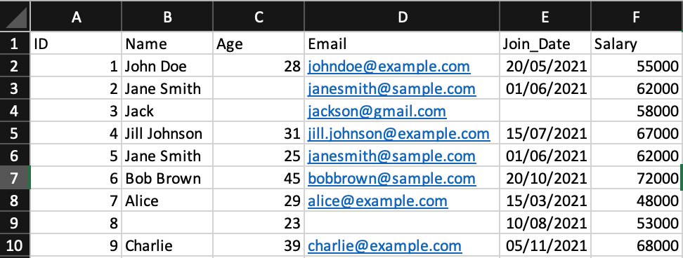

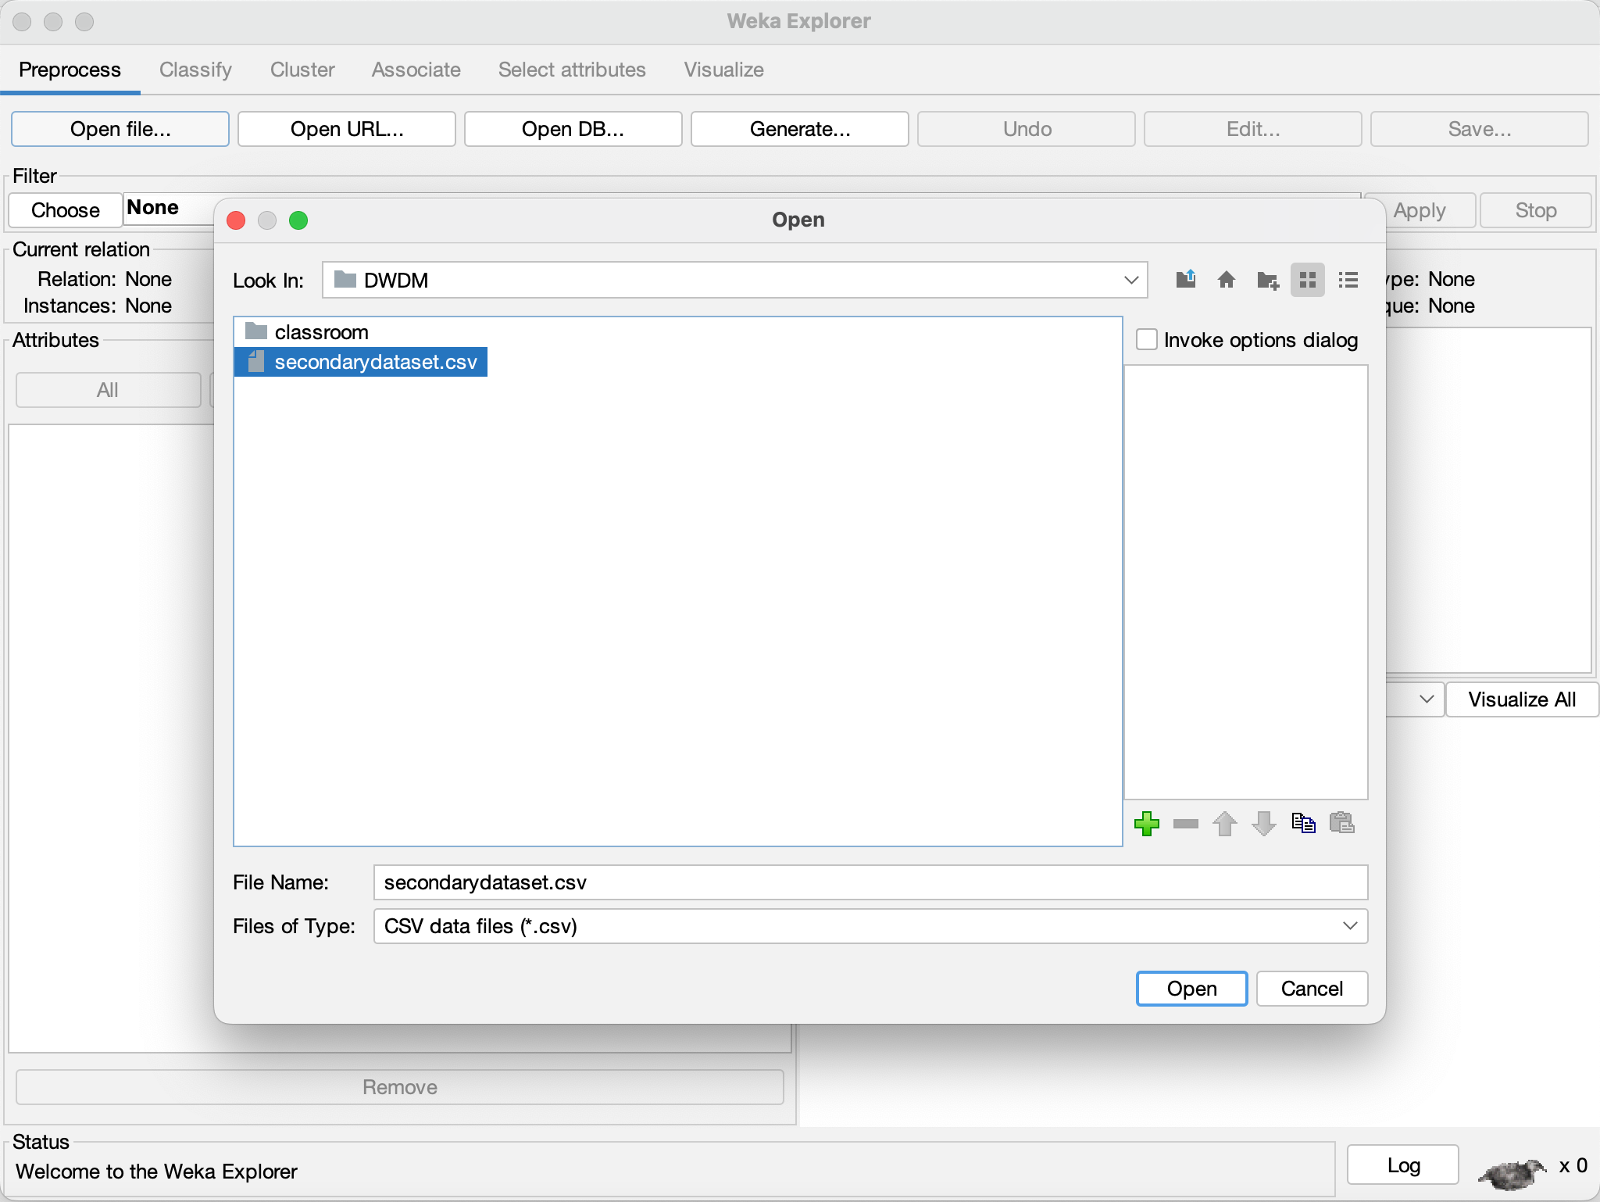

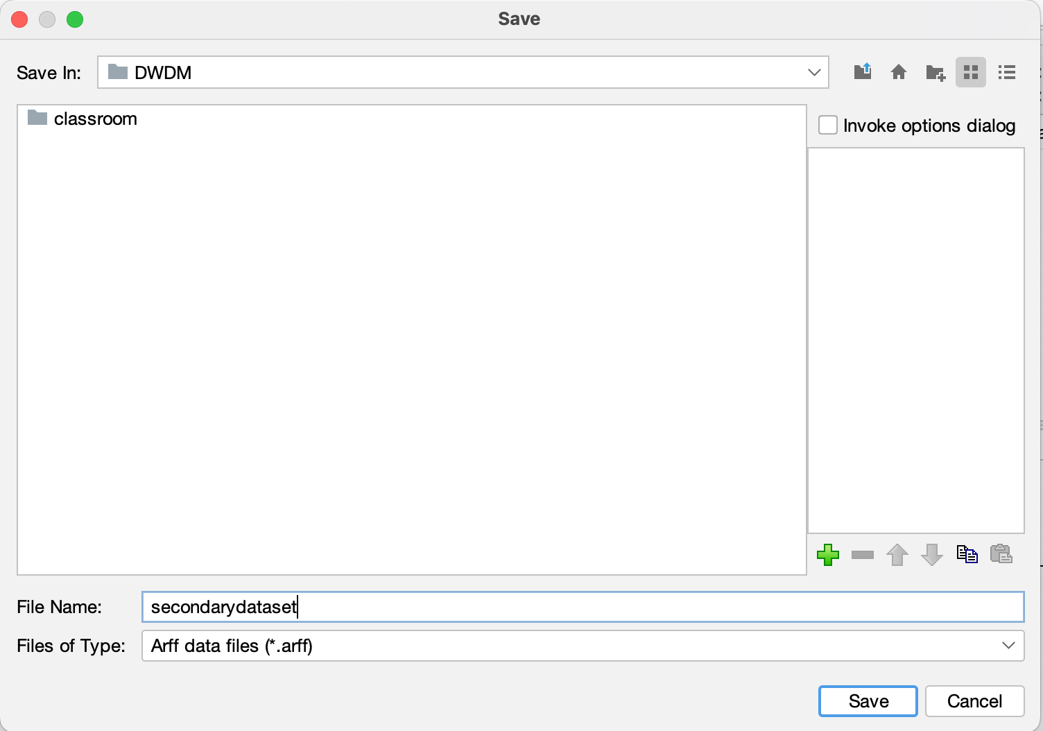

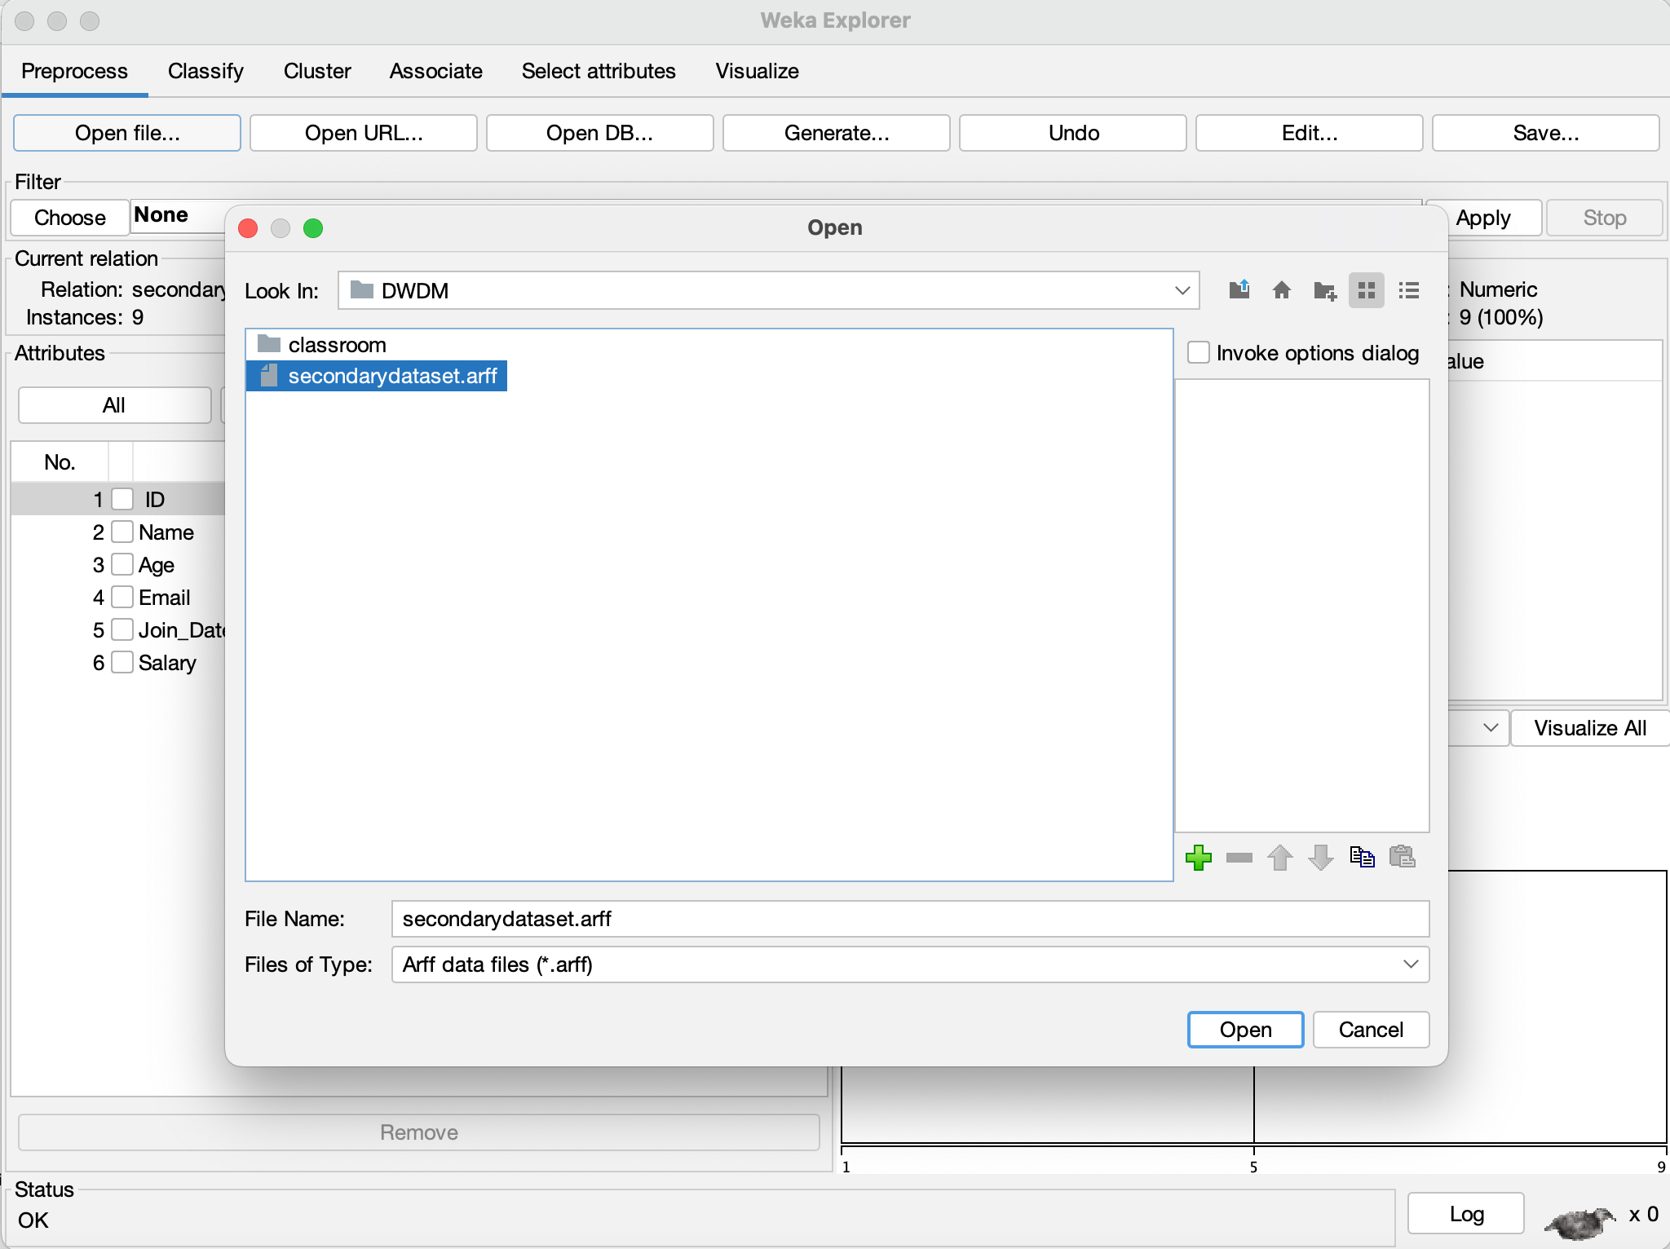

**2. Dataset before preprocessing:**

Before preprocessing, the dataset is in its raw form and may contain issues like missing values, duplicate entries, or inconsistent data that need to be fixed.

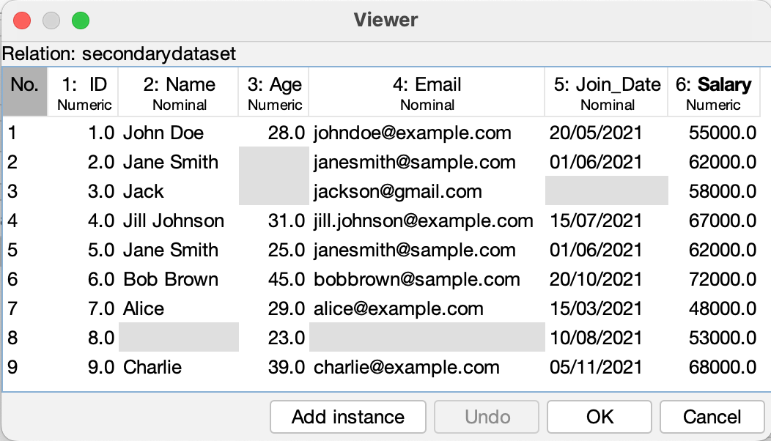

**3. Handling Missing Values:**

• Go to the **"Filter"** tab in WEKA.

• Select **unsupervised.attribute.ReplaceMissingValues**.

• This filter automatically fills in missing values using methods like the mean (for numbers) or mode (for categories).

• Apply the filter to clean up the missing data.

**4. Dataset after preprocessing:**

Once preprocessing is complete, the dataset will be cleaner, with missing values handled, making ready for accurate analysis.

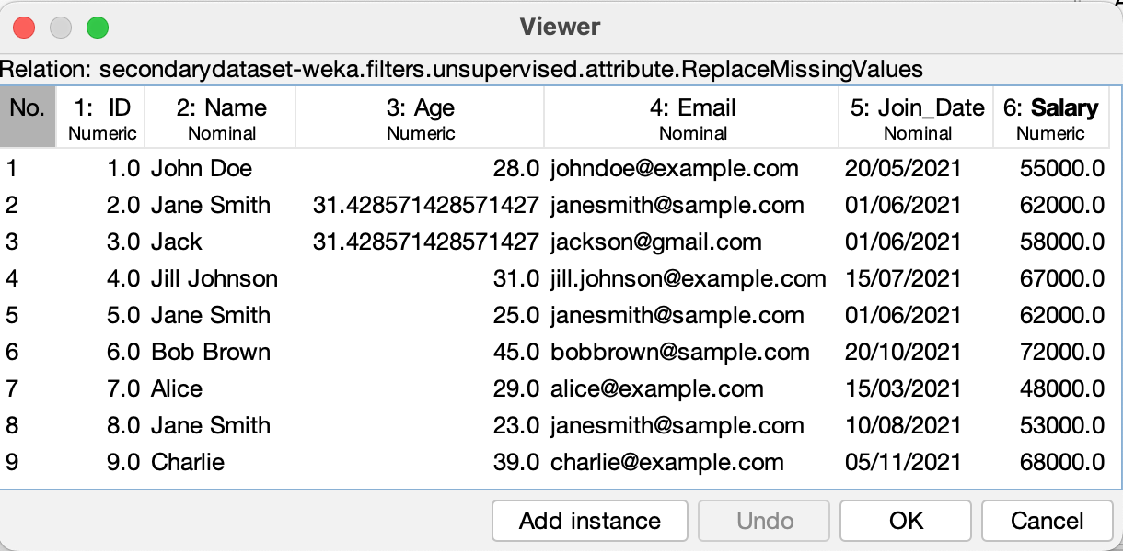

#### **Q2.) Steps for Preprocessing Primary Datasets**

##### **Student Records Dataset**

**1. Select the appropriate primary dataset**

Click on the Open file button and select the student records dataset in .arff format from the relevant destination.

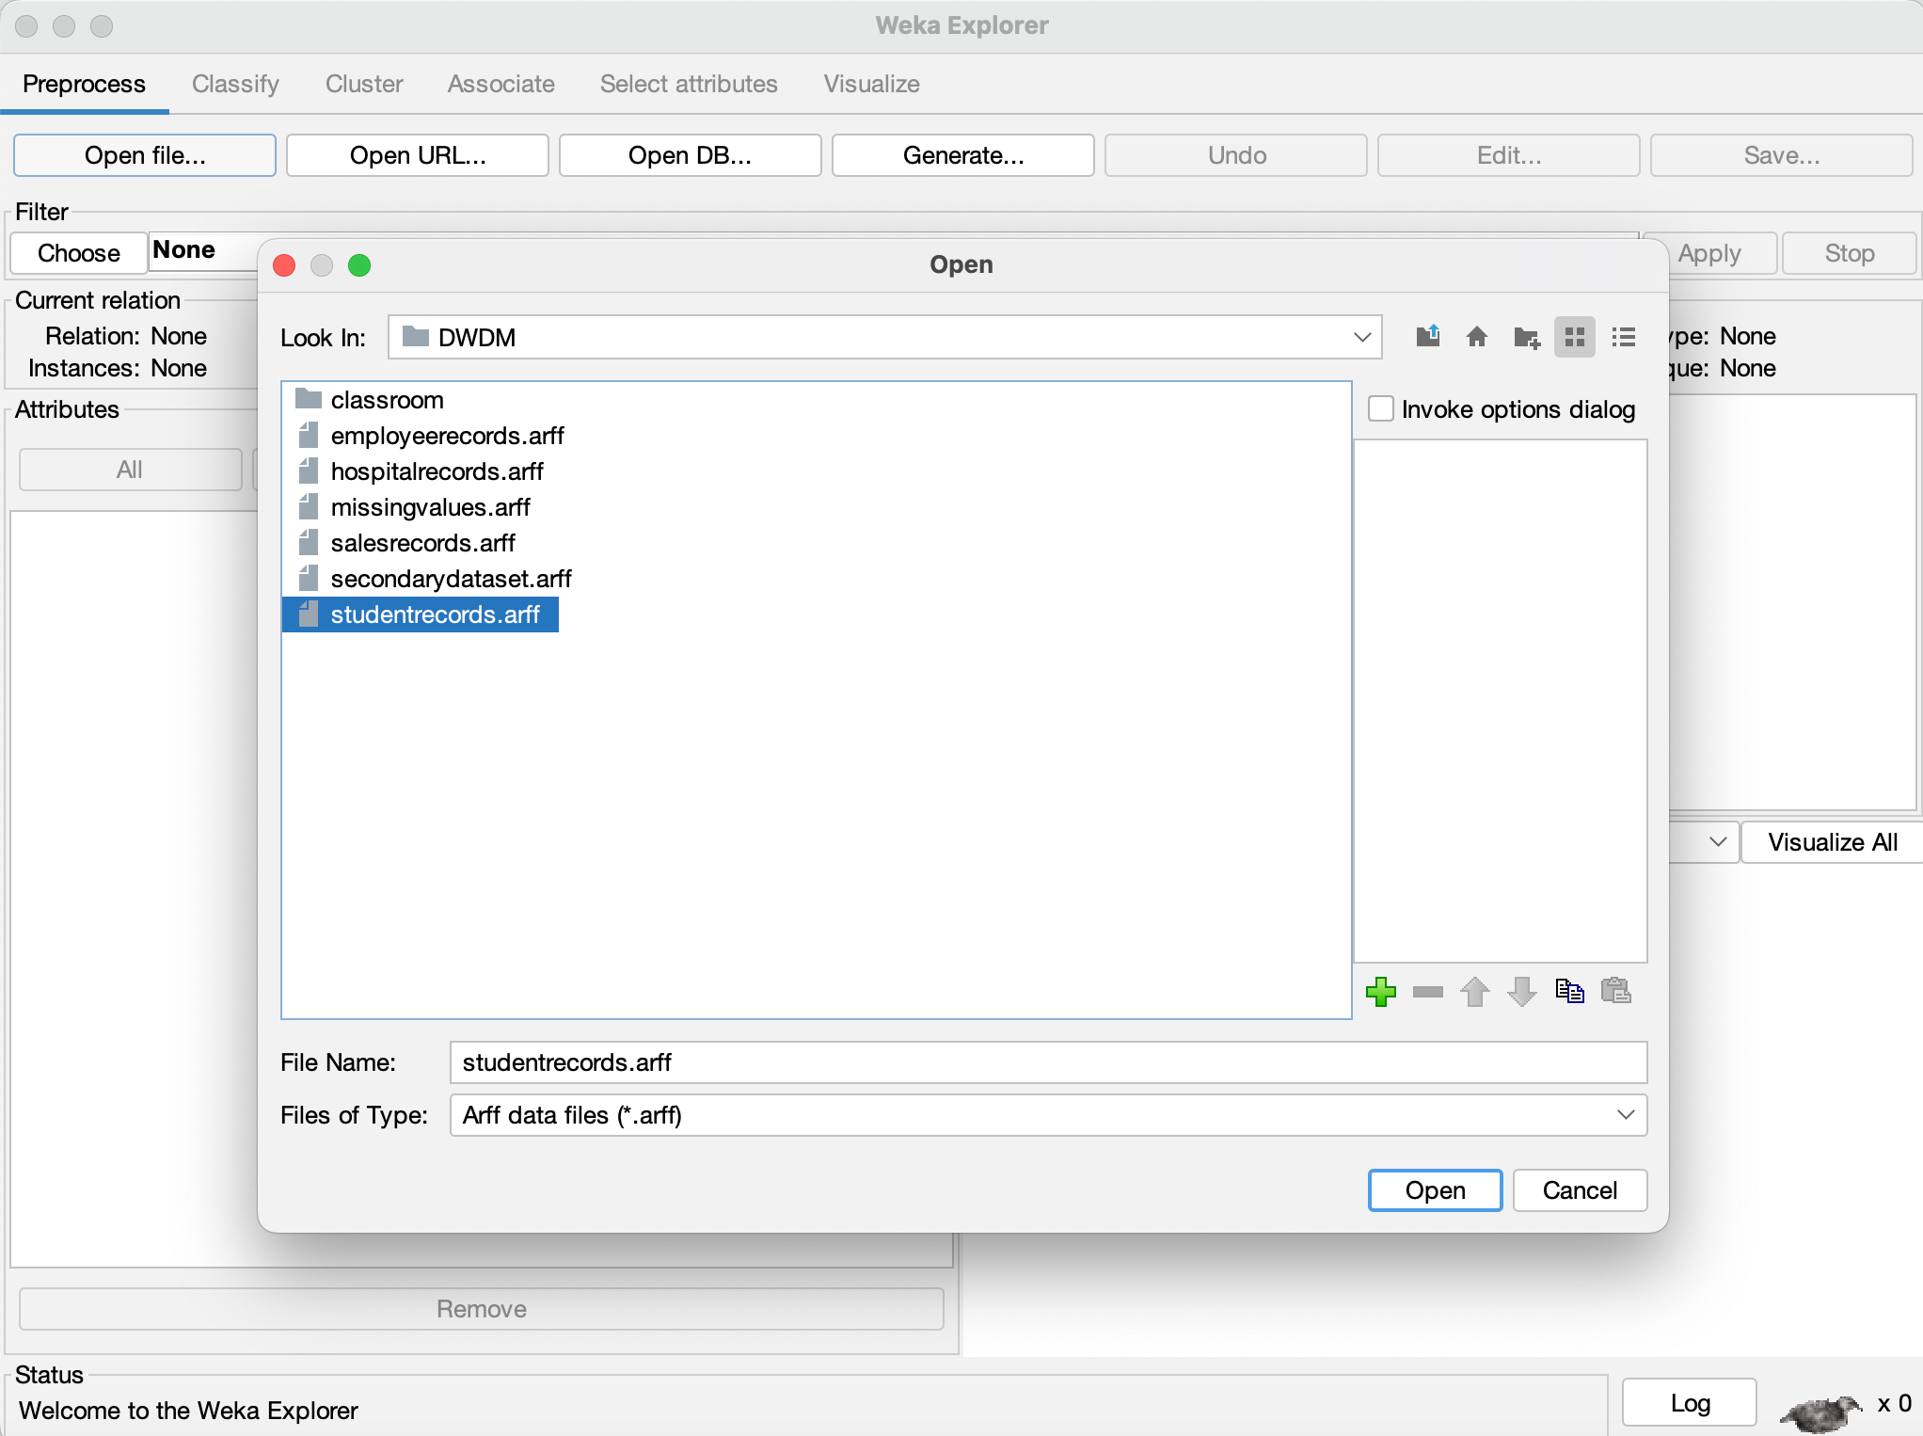

**2. Loaded Dataset** : Load the dataset into WEKA's Explorer.

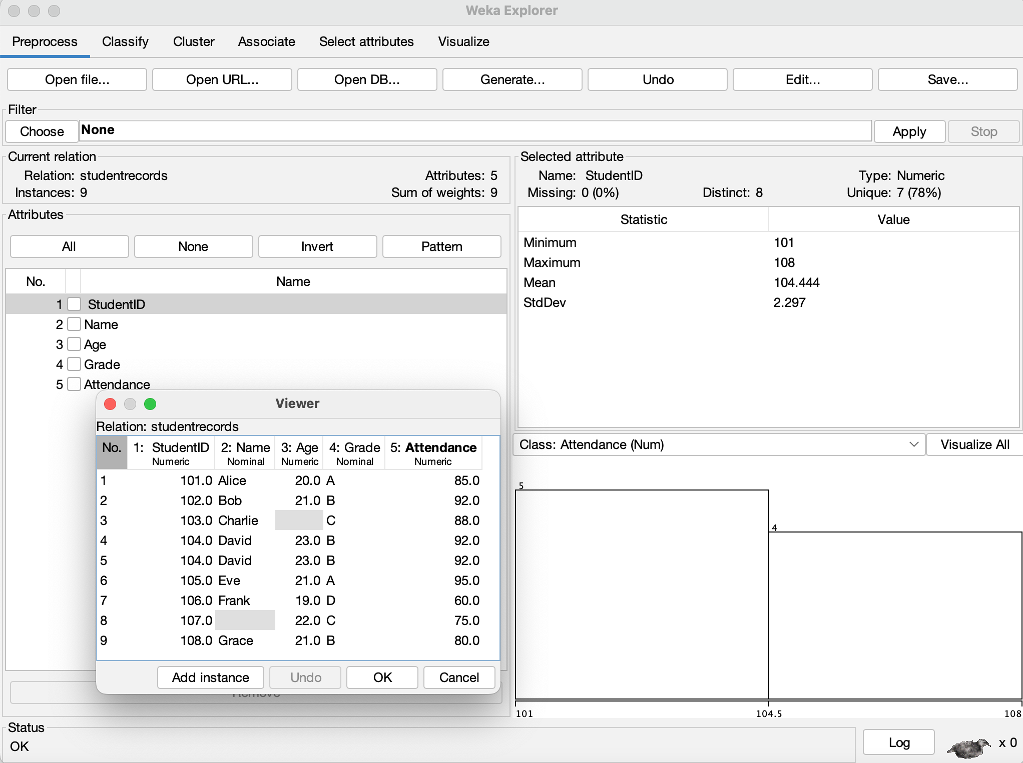

**3. Handle Missing Values**

Choose the **Filter** option and select **unsupervised.attribute.ReplaceMissingValues**. Click on the Apply button to handle missing values.

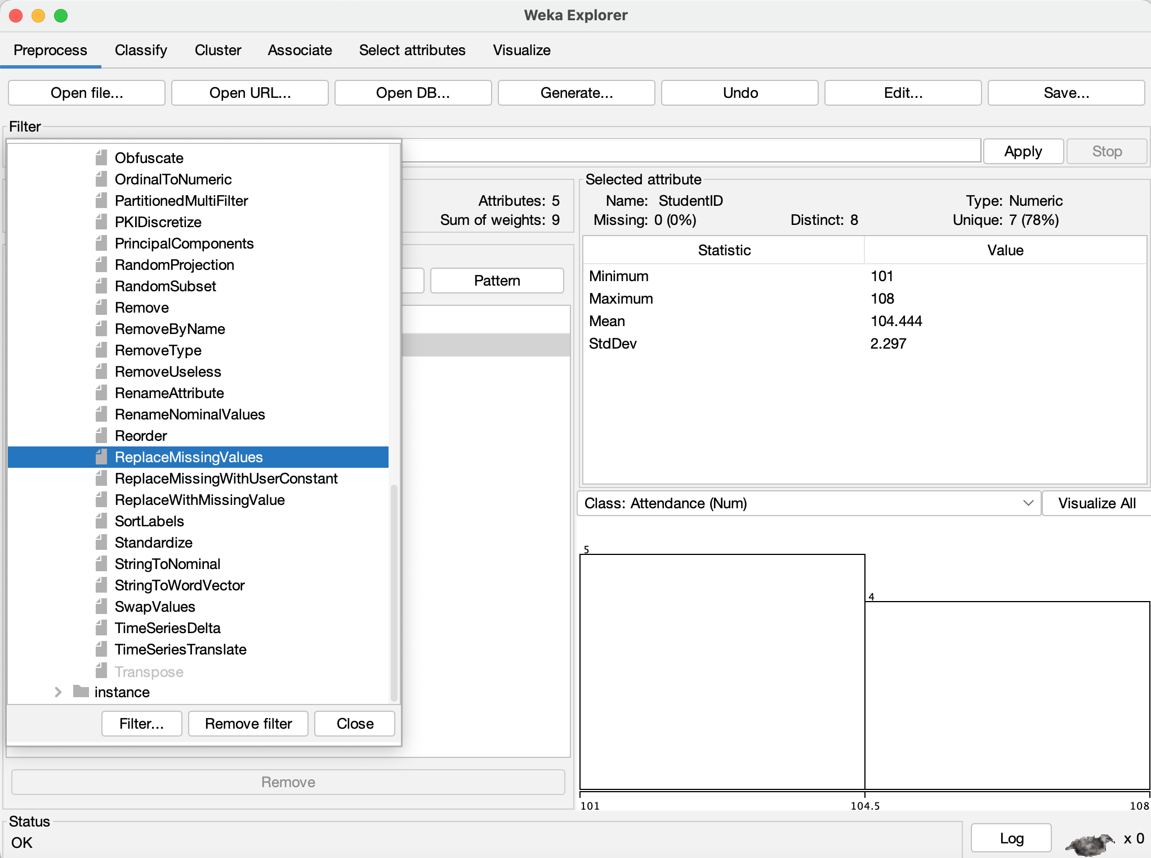

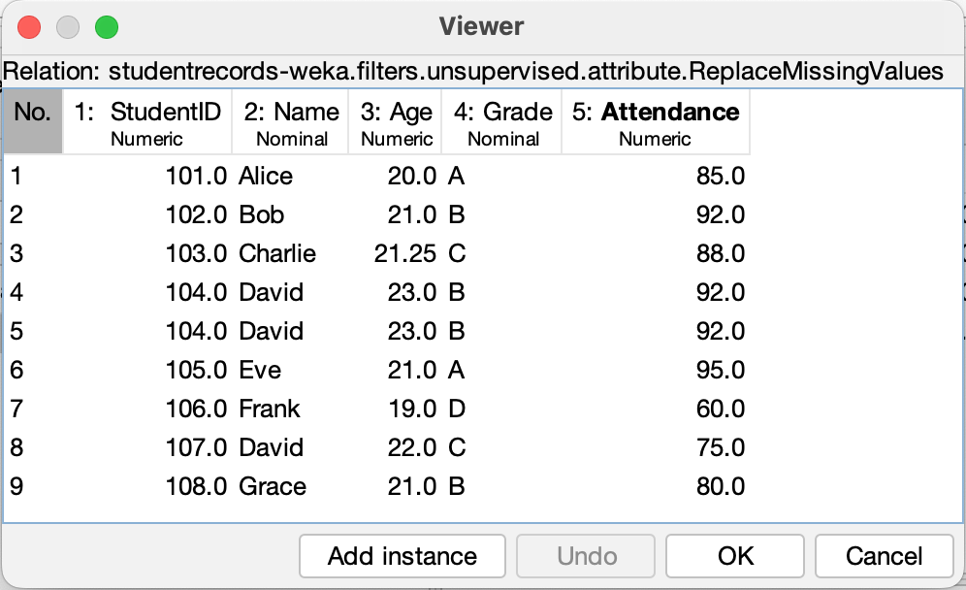

**4.Remove Duplicates**

Select the **RemoveDuplicates** filter from the **Filter** option and apply it.

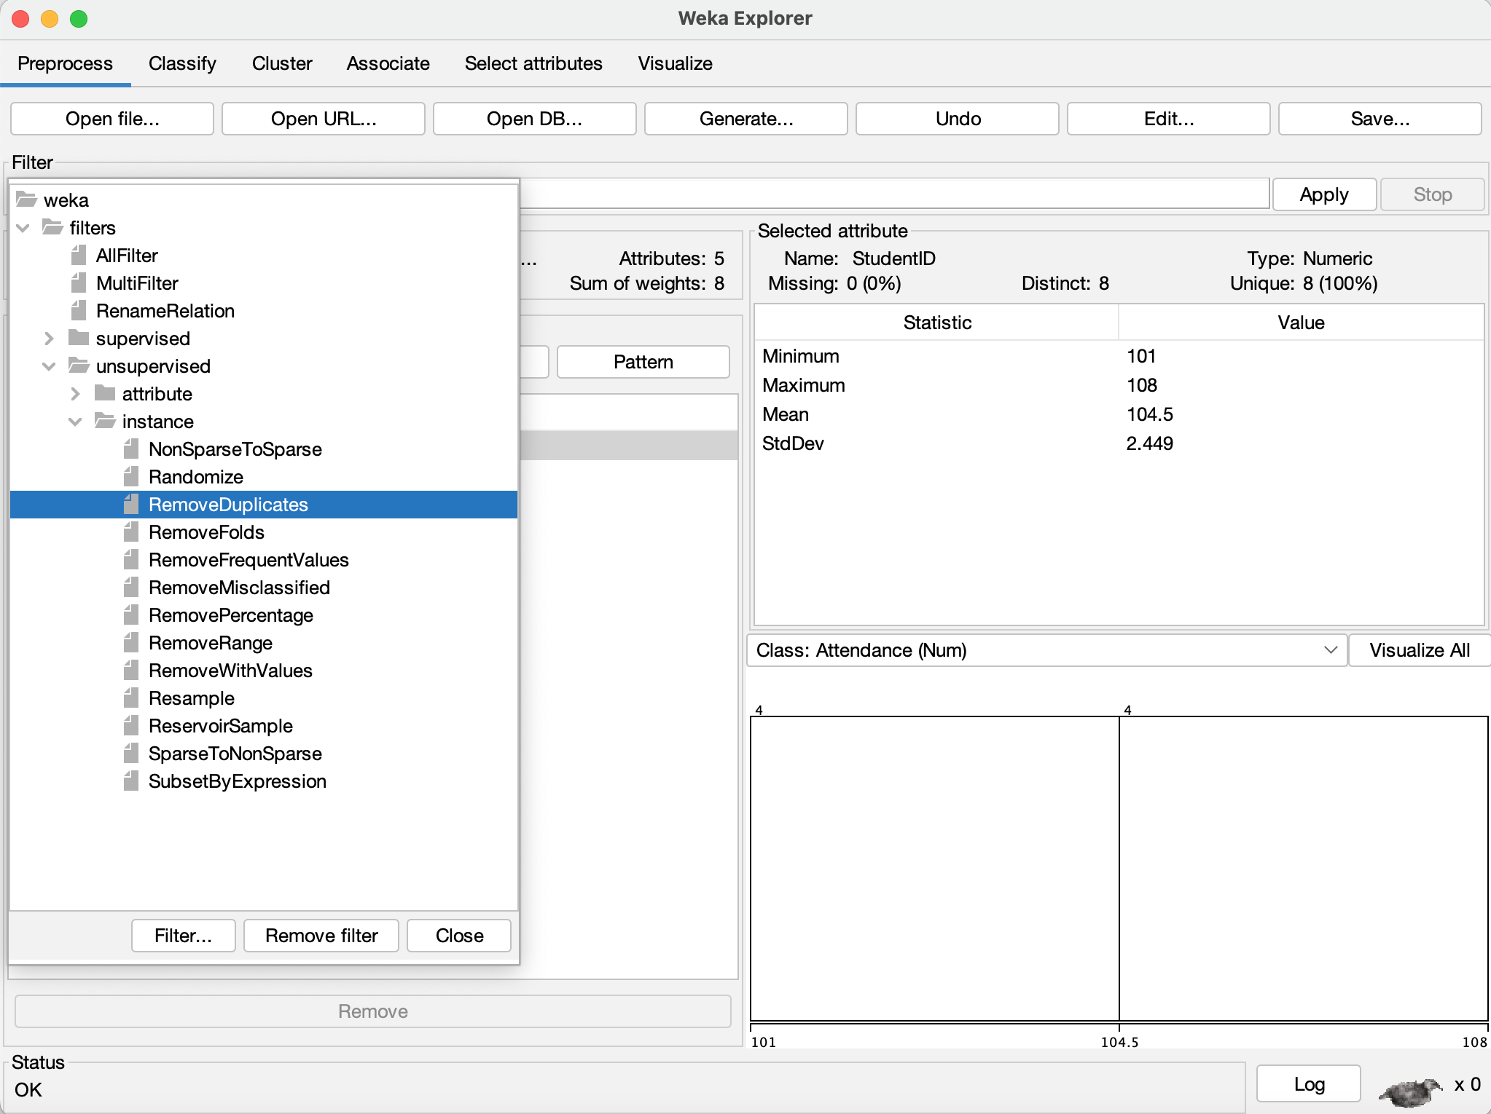

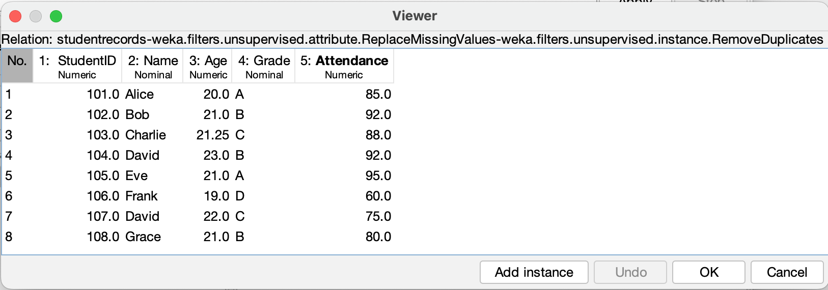

**Hospital Records Dataset**

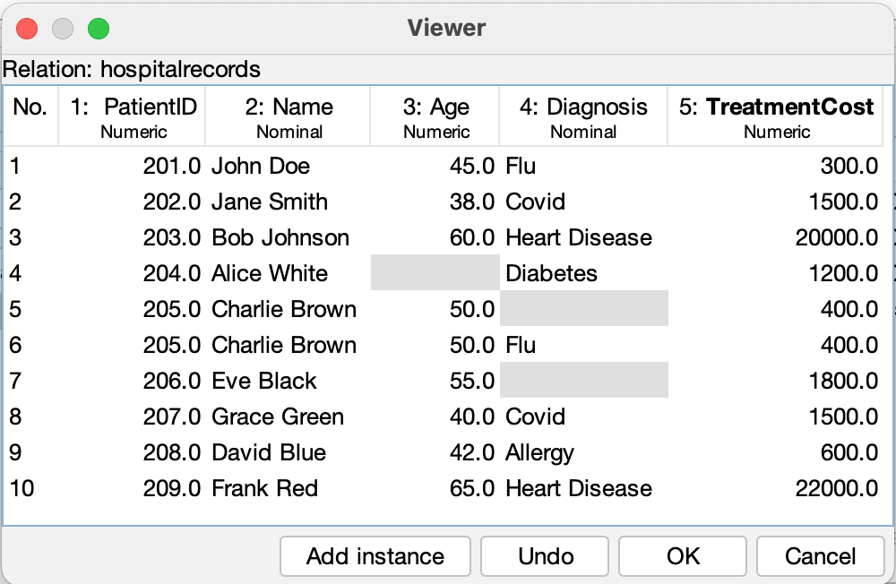

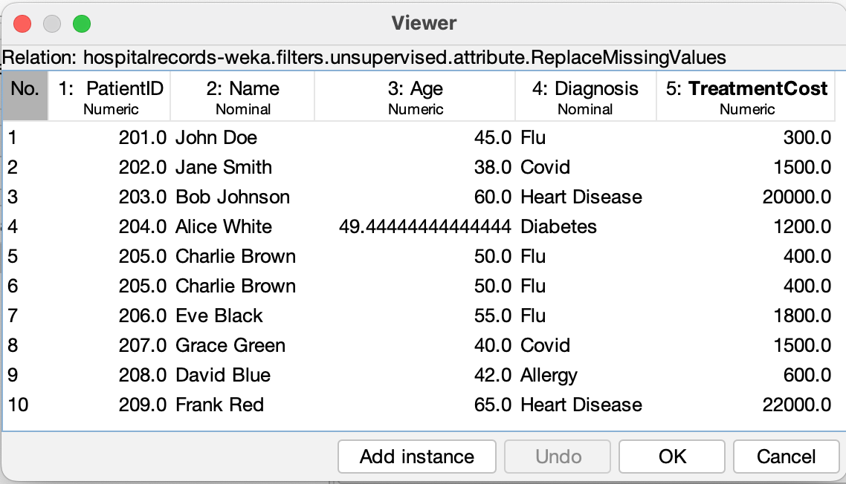

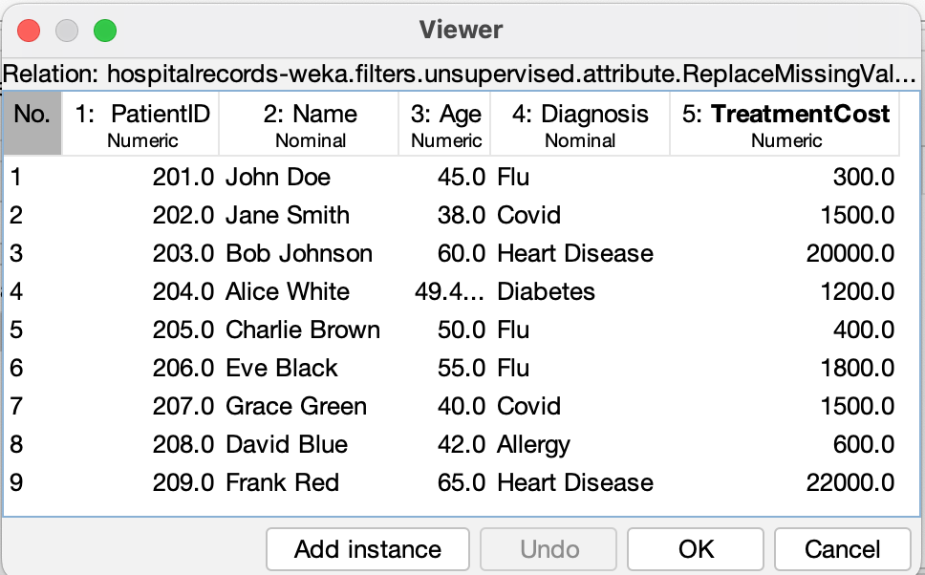

**Employee Records Dataset**

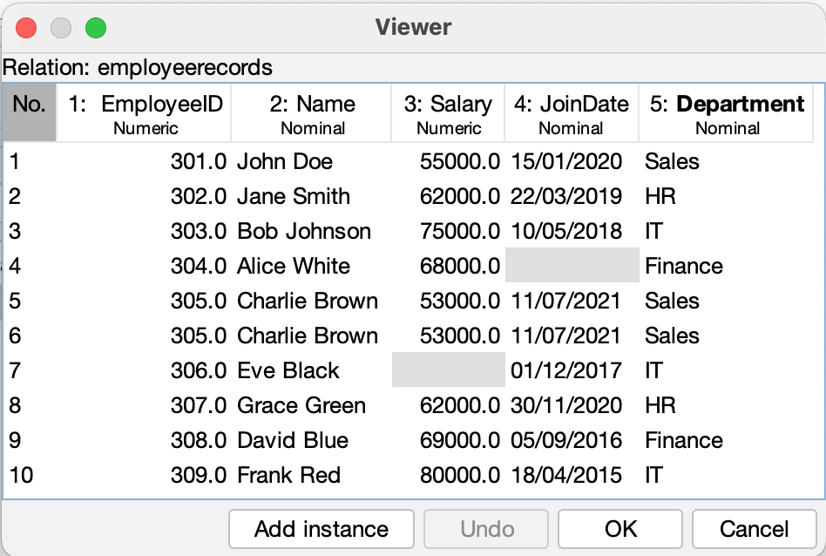

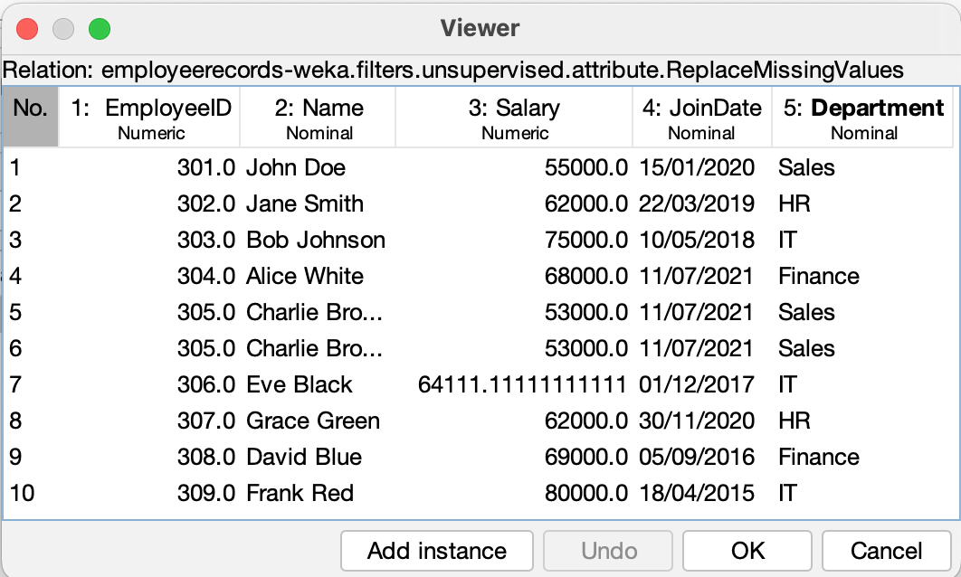

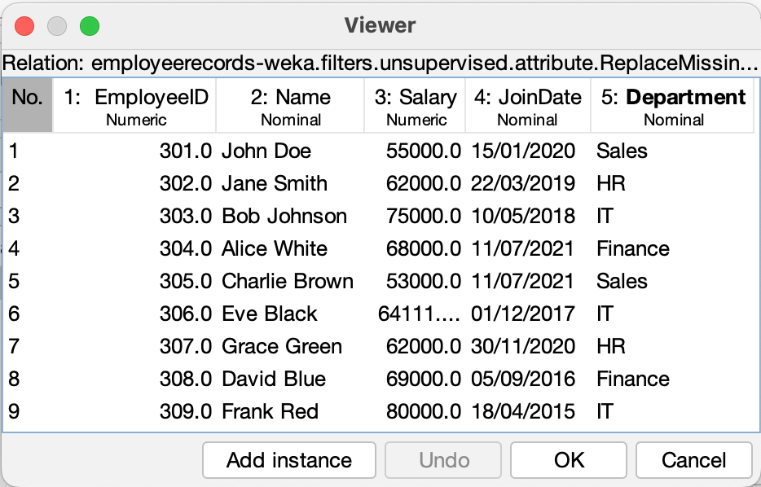

**Sales Records Dataset**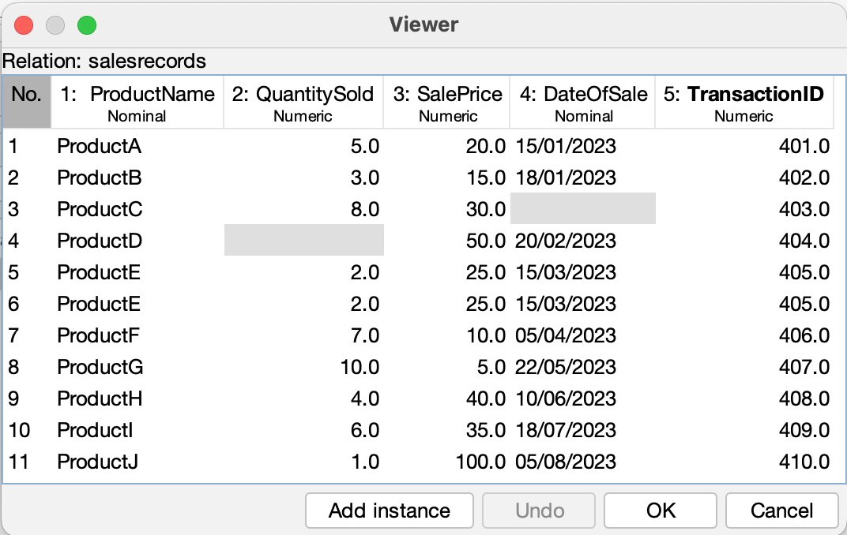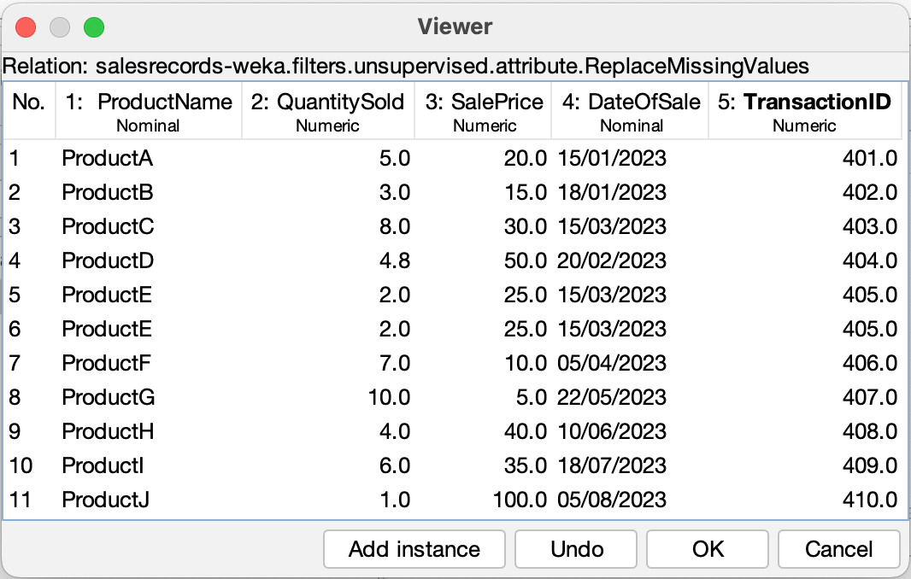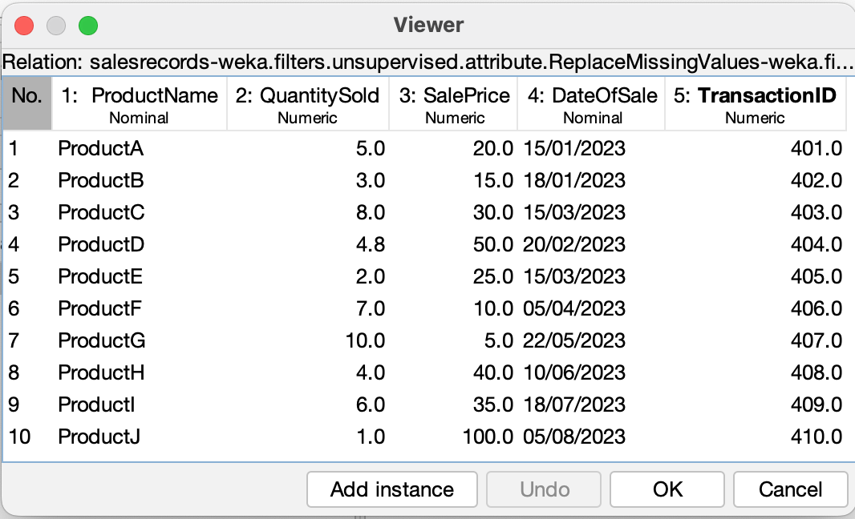

### Discussion:

### Applying preprocessing steps to both primary and secondary datasets greatly improved their quality. Handling missing values, removing duplicates, and transforming data were essential for making the datasets clean and analysis-ready. These steps help minimize errors and ensure consistent, trustworthy results. Visual comparisons of the data before and after preprocessing clearly show the benefits, making the data more reliable for future use.

### Conclusion:

In this lab, we used WEKA and Excel to clean multiple datasets by addressing missing values, duplicates, outliers, and inconsistencies. The preprocessing steps significantly improved data quality. The cleaned datasets are now ready for accurate analysis and modeling, leading to more dependable insights.

**ST. XAVIER’S COLLEGE**

**Maitighar, Kathmandu**

**(Affiliated to Tribhuvan University)**



**LAB REPORT ON**

**DATA MINING AND DATA WAREHOUSING (IT 308)**

**SUBMITTED BY:** **SUBMITTED TO:**

**Name: Shashank Acharya Er. Anuj Shrestha**

**Faculty/Semester: BIM/8th (NEC Registration No.:5495)**

**Roll No.: 020BIM045 Lecturer,**

**Dept. of Computer Science**

## Lab Number: 3

### Title: Preparing a Numeric Type Primary Dataset and Performing Discretization

### Objective: To create a numeric primary dataset and apply discretization techniques using WEKA.

### IDE/Tools used: MsExcel, WEKA

### Theory:

Discretization is an important data preprocessing technique used in data mining to convert continuous numeric attributes into discrete categories. This is especially useful for algorithms like decision trees, which perform better with categorical data.

**How Discretization Works:**

The process involves dividing the range of continuous values into intervals (or "bins") and assigning each value to a specific bin. This reduces data complexity and helps reveal meaningful patterns.

**Common Discretization Methods:**

1. **Equal-Width Binning:**
   * Divides the range into equal-sized intervals.
   * Example: Age groups (0-20, 21-40, 41-60).
2. **Equal-Frequency Binning:**
   * Ensures each bin has an equal number of data points.
   * Example: Dividing 100 salaries into 5 bins, each containing 20 values.
3. **Clustering-Based Discretization:**
   * Uses clustering algorithms (like K-means) to form bins based on the data itself.

**Example Attributes for Discretization:**

* **Age** (e.g., "Young," "Middle-aged," "Senior")
* **Salary** (e.g., "Low," "Medium," "High")
* **Temperature** (e.g., "Cold," "Moderate," "Hot")

Discretization simplifies data, makes models more interpretable, and improves performance by reducing noise and variance in continuous attributes.

# Implementation:

**Ql) Steps for Data Discretization**

**#Select appropriate dataset**

Click on the Open file button and select the primary dataset in .csv format from the relevant destination.

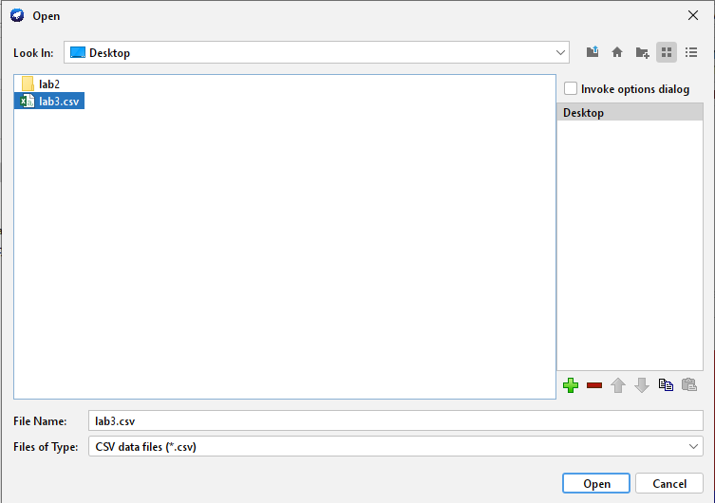

# #Loaded dataset

Click on the 'Edit' button to view the loaded dataset.

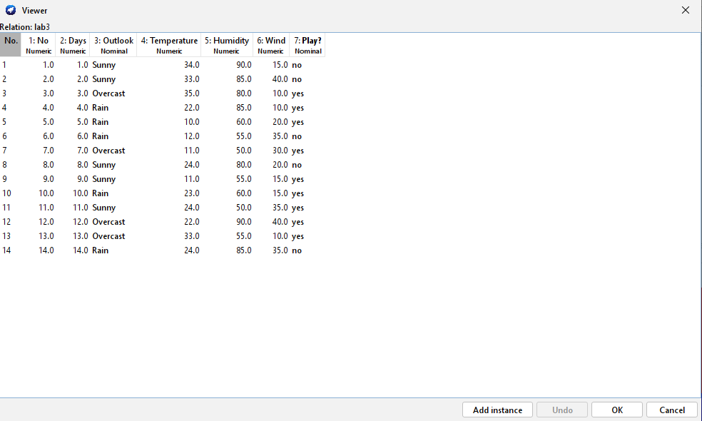

The above dataset contains three columns with numeric values i.e., Temperature, Humidity and Wind. We need to discretize these values using Weka.

# #Discretizing Temperature

Apply the 'Discretize' filter which is under the unsupervised filters inside the attribute section. This will change the values of the temperature column so that it is easy to discretize them.

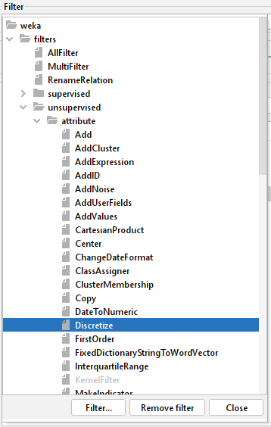

**#Configure filter**

First, we configure the filter so that the values in the temperature column can be divided into three bins

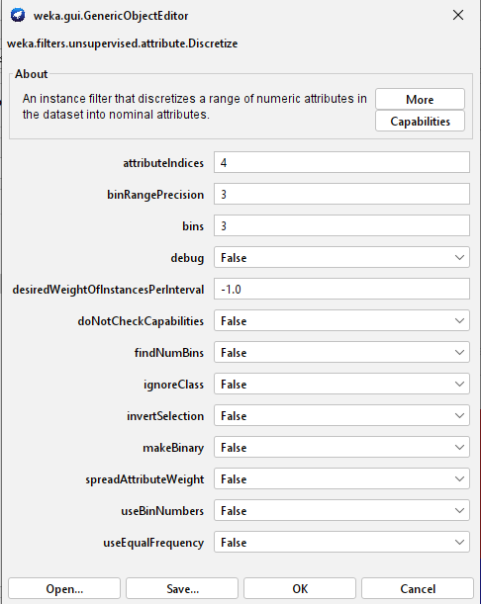

**#Discretized Temperature Column:**

After discretization, the **Temperature** column is divided into three distinct groups, each representing a range of values. The column now contains three categories, making the data more interpretable and ready for use in algorithms that work with categorical values.

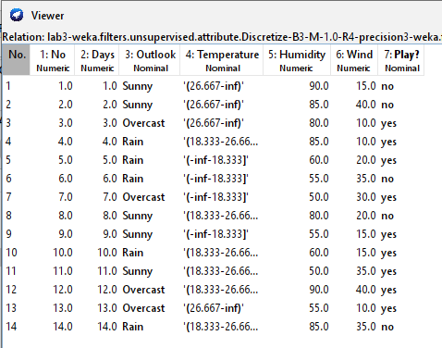

**#Discretization of Humidity and Wind:**

Unlike Temperature, which was divided into three bins, the Humidity and Wind attributes were discretized into just two categories each:

* Humidity is now grouped into two levels based on predefined thresholds (e.g., *Low* and *High* humidity).
* Wind is similarly split into two categories, reflecting different intensity levels (e.g., *Weak* and *Strong*).

**Final Dataset After Discretization:**

After applying discretization, the dataset now contains categorical values for Temperature, Humidity, and Wind. This transformation enhances interpretability and makes the data more compatible with classification algorithms like decision trees.

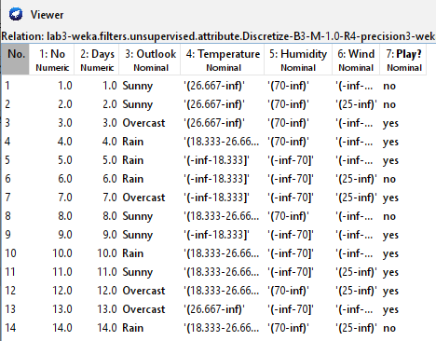

**Renaming Nominal Values in WEKA:**

After discretizing numeric attributes, WEKA assigns default bin names like “bin1,” which can be unclear. To make your dataset more understandable:

1. **Load** the discretized dataset in WEKA.
2. Go to the **"Filter"** tab and select **unsupervised.attribute.RenameNominalValues**.
3. Manually rename each bin to something meaningful (e.g., change "bin1" to "Low Income").
4. Click **"Apply"** to update the dataset with the new, readable labels.

This step improves data clarity and helps make analysis results more interpretable.

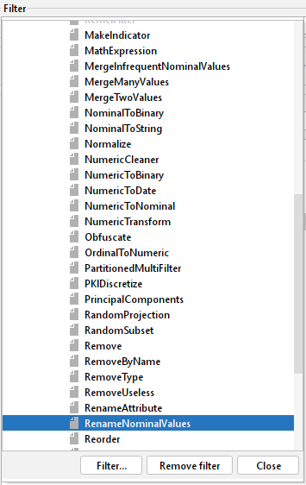

# First, we rename the temperature column.

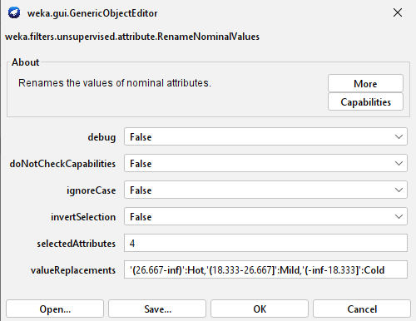

Then the humidity column.

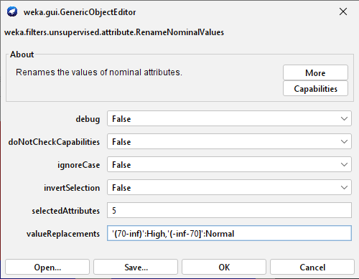

And the wind column is also renamed.

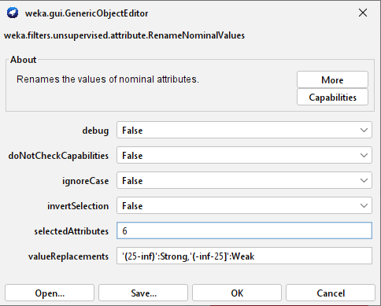

Finally, after renaming all those columns, we get a proper readable discretized dataset as following:

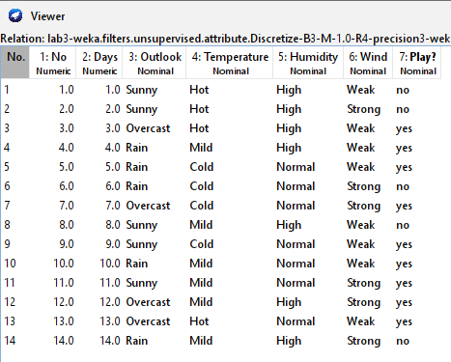

**Discussion:**

Discretization is an important preprocessing step that turns continuous numeric values into categories or bins, which helps certain algorithms—like decision trees—perform better. The method used (such as equal-width, equal-frequency, or clustering) can influence the results. In this lab, we discretized features like Age, Income, and Spending Score, making them easier to interpret and better suited for categorical algorithms.

**Conclusion:**

In this lab, we used WEKA to discretize a numeric dataset. We loaded the data, applied a discretization filter, and renamed the resulting bins for clarity. This step enhanced data interpretability and compatibility with specific algorithms, highlighting the value of discretization in the preprocessing pipeline.

**ST. XAVIER’S COLLEGE**

**Maitighar, Kathmandu**

**(Affiliated to Tribhuvan University)**



**LAB REPORT ON**

**DATA MINING AND DATA WAREHOUSING (IT 308)**

**SUBMITTED BY:** **SUBMITTED TO:**

**Name: Shashank Acharya Er. Anuj Shrestha**

**Faculty/Semester: BIM/8th (NEC Registration No.:5495)**

**Roll No.: 020BIM045 Lecturer,**

**Dept. of Computer Science**

# Lab Number: 4

**Title**: Using ID3 and J48 algorithm to design decision trees using a primary dataset.

**Objective**: To classify a primary dataset using decision trees in WEKA, specifically applying the ID3 and J48 algorithms to understand their performance and compare results.

**IDE/Tools used**: Weka.

# Theory

**Decision Tree Algorithms:**

A decision tree is a machine learning model used for classification tasks, where each node represents a decision based on a feature, and the leaf nodes represent the class labels or outcomes. Two popular decision tree algorithms are ID3 and J48.

1. **ID3 (Iterative Dichotomiser 3):**
   * Uses entropy and information gain to split the data.
   * Selects the best attribute based on the highest information gain at each node.
   * Only works with categorical data.
2. **J48:**
   * An implementation of the C4.5 algorithm.
   * Can handle both continuous and categorical data.
   * Performs pruning to avoid overfitting and improve generalization.

**Cross-Validation:**

Cross-validation is a technique for evaluating a model's performance. In k-fold cross-validation, the dataset is divided into k parts (folds). The model is trained on k-1 folds and tested on the remaining fold, repeating this process k times for reliable performance estimation.

**Implementation**

## Steps for using ID3 Algorithm

### Step 1: Select the Appropriate Primary Dataset

Load the dataset in .arff format, which is the required format in WEKA.

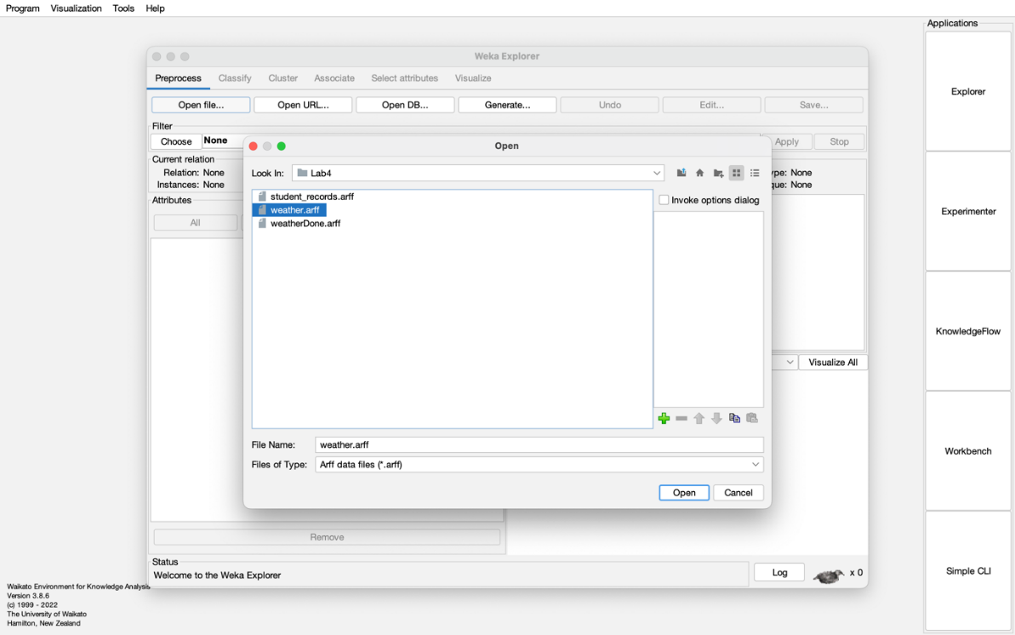

Figure 1: Selecting the Appropriate Primary Dataset

### Step 2: Loaded Dataset

Once the dataset is loaded into WEKA, it's important to check that everything has been loaded correctly. This step ensures that all attributes and instances are present, and there are no issues with the dataset file.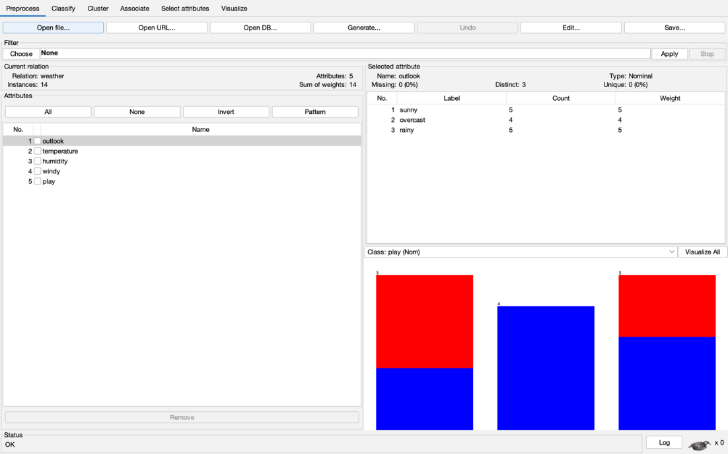

Figure 2: Loading the Nominal Dataset

### Step 3: Apply the ID3 Algorithm

Navigate to the "Classify" tab in WEKA, and choose the ID3 algorithm from the "trees" category

.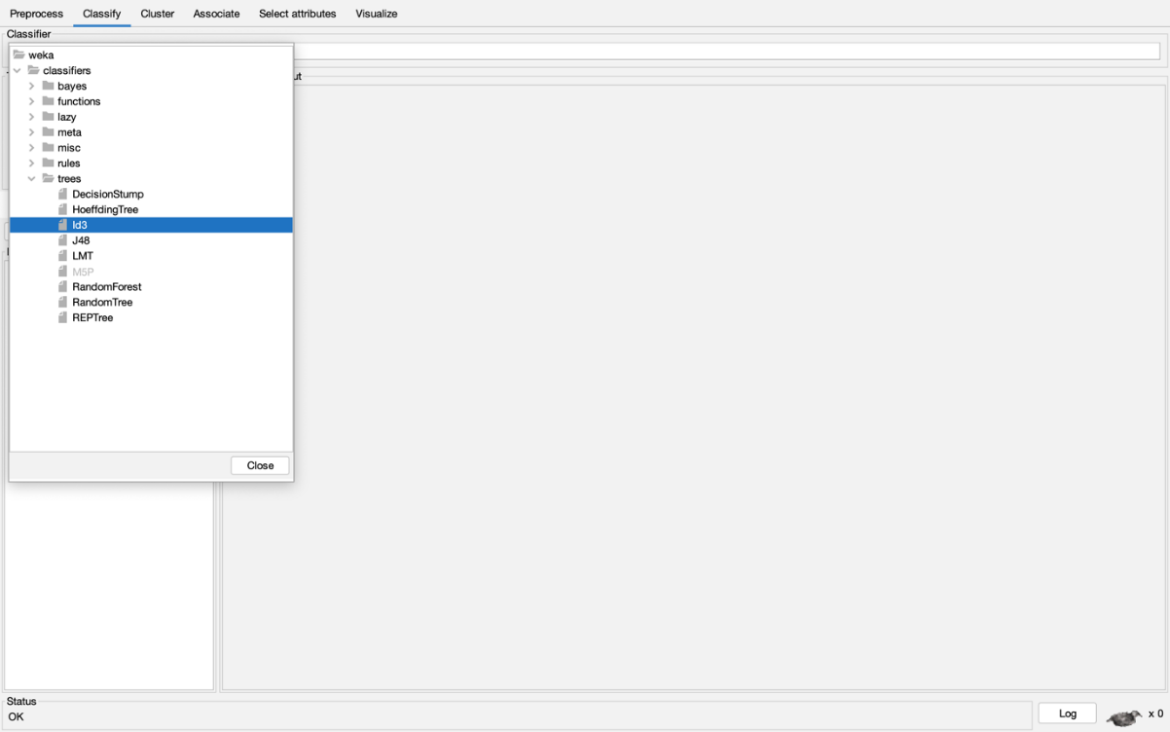

Figure 3: Choose ID3 Algorithm

### Step 4: Configure and Run the ID3 Algorithm

Set the parameters for cross-validation (typically 10-fold) and run the algorithm.

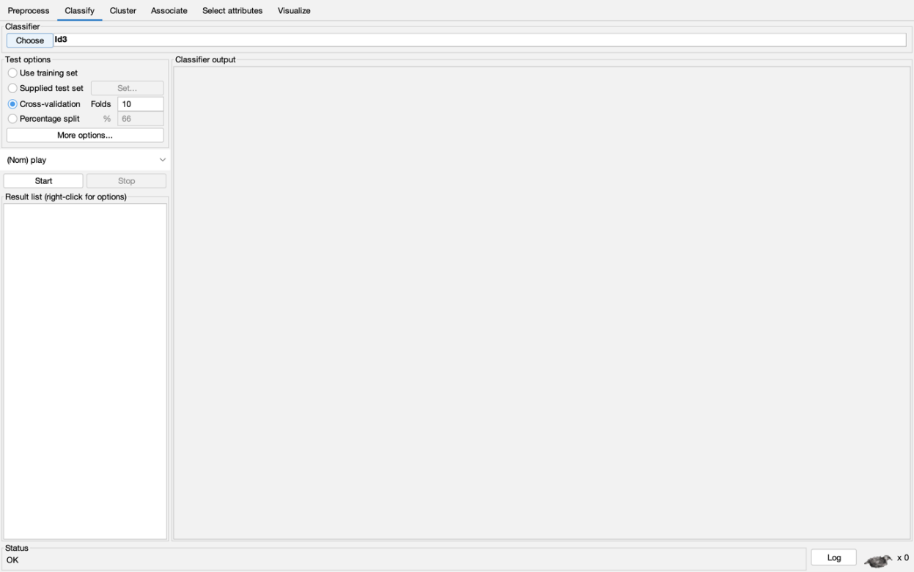

Figure 4: Configure ID3 Algorithm

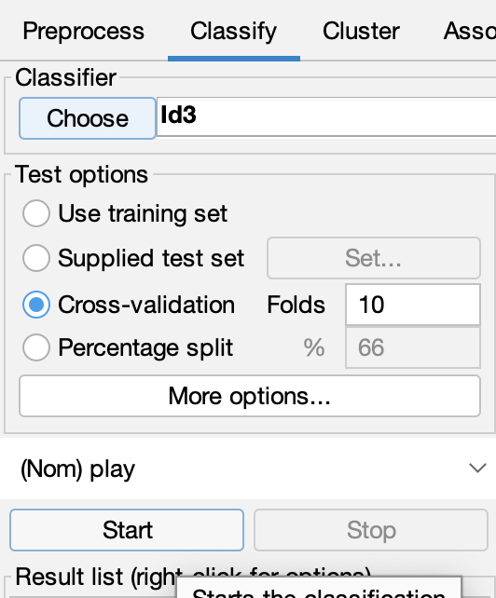

Figure 5: Run ID3 Algorithm

### Step 5: Classification Details (Resultant)

Review the decision tree structure and the performance metrics such as accuracy, precision,and recall.

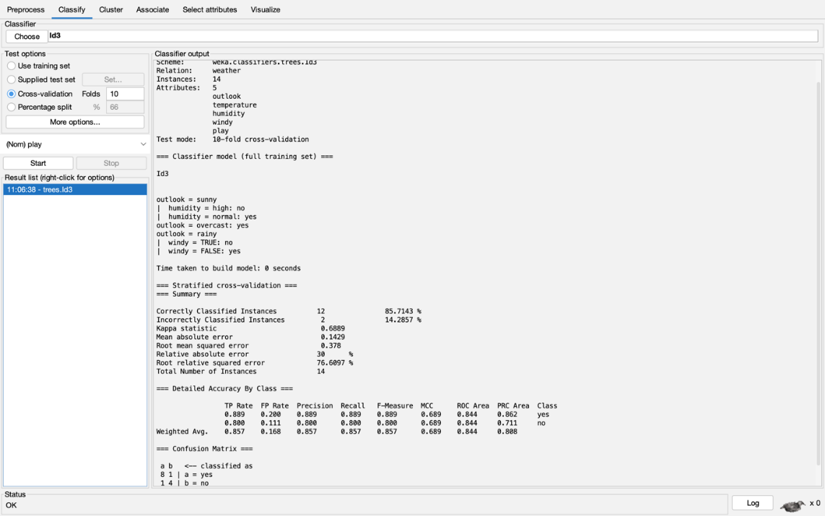

Figure 6: Output of ID3 Algorithm

By following these steps, we can effectively use the ID3 algorithm in Weka to classify your dataset and analyze the resulting decision tree and performance metrics.

## Steps for using J48 Algorithm

### Step 1: Select the Appropriate Primary Dataset

Same as with the ID3 algorithm, load the dataset in .arff format.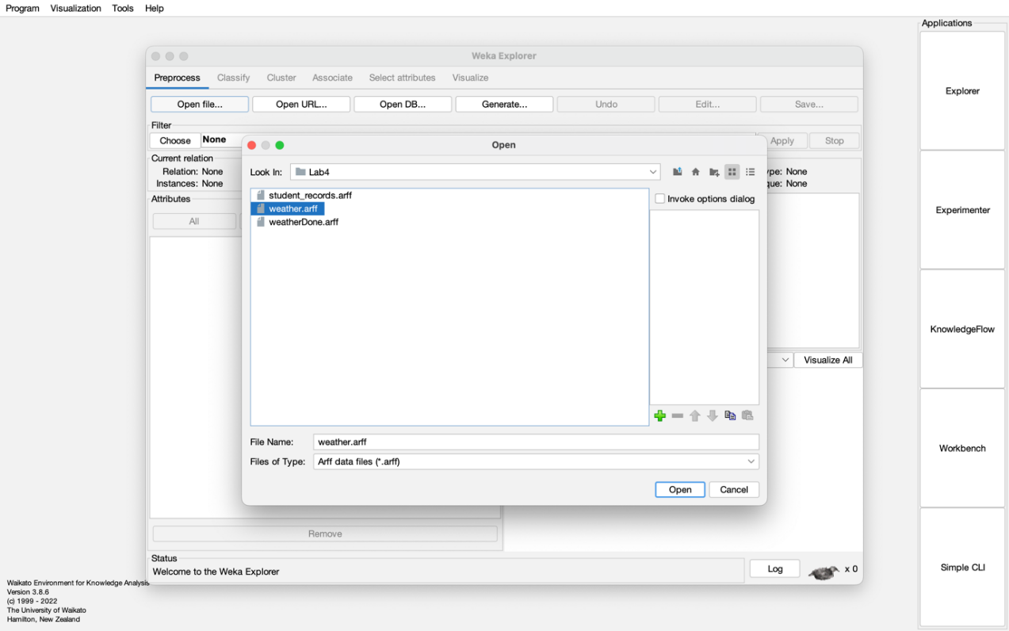

Figure 7: Selecting the Appropriate Primary Dataset

### Step 2: Loaded Dataset

Verify that the data is correctly loaded and ready for classification.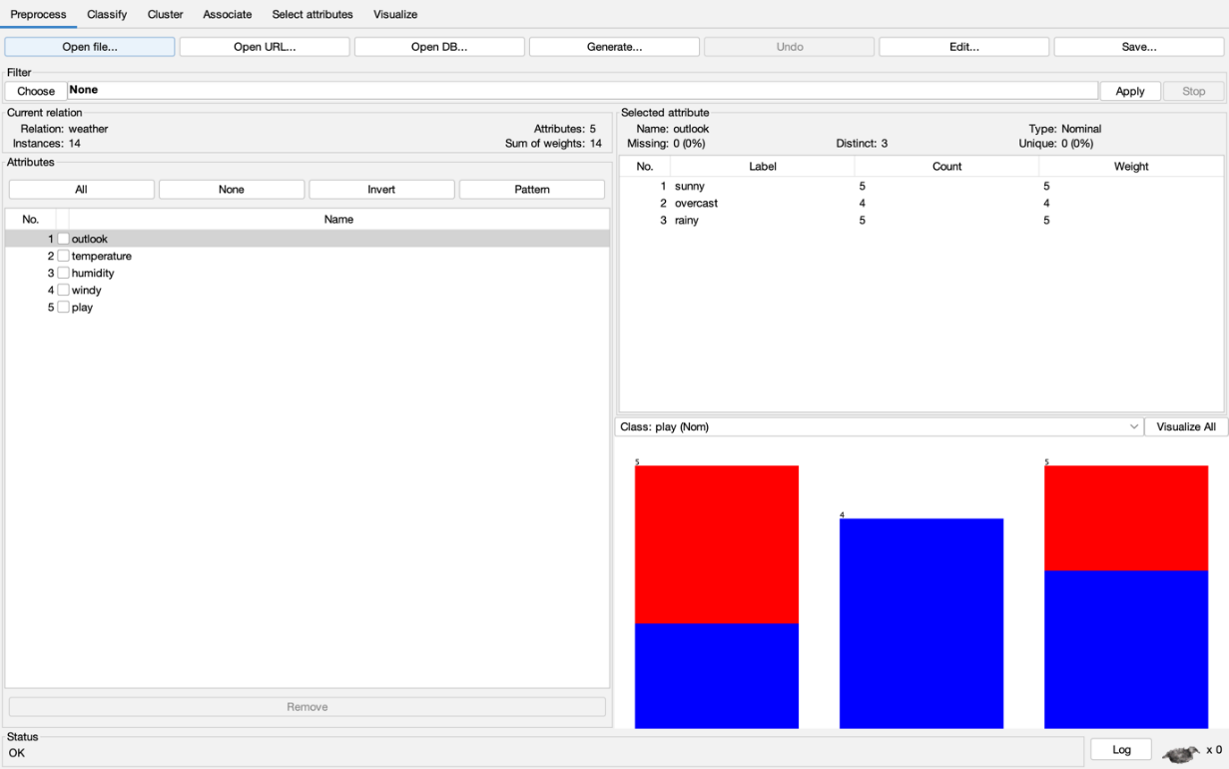

Figure 8: Load data in Weka

### Step 3: Apply the J48 Algorithm

Navigate to the "Classify" tab, and select the J48 algorithm from the "trees" category.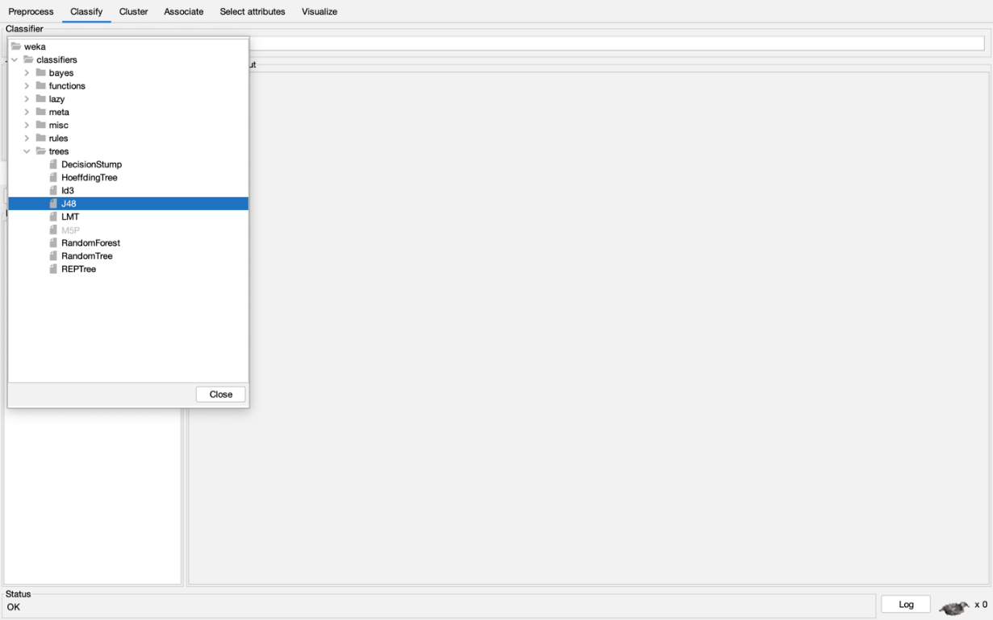

Figure 9: Configure the algorithm

**Step 4: Run the J48 Algorithm**

* Click on the "Start" button to initiate the classification process.

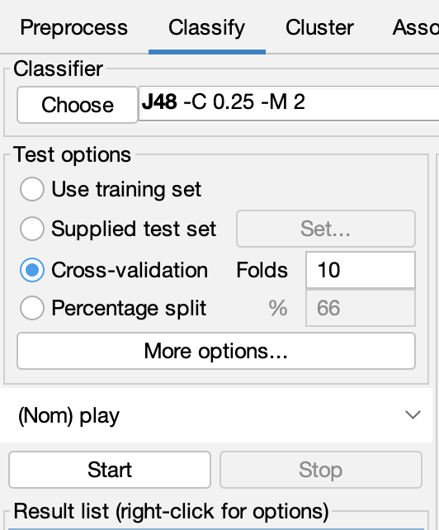

Figure 10: Start button to run the algorithm

**Review the Classification Details**

* The "Classifier output" section provides detailed information about the classification process.
* It includes the decision tree, accuracy statistics, and other key metrics that show how well the model performed.

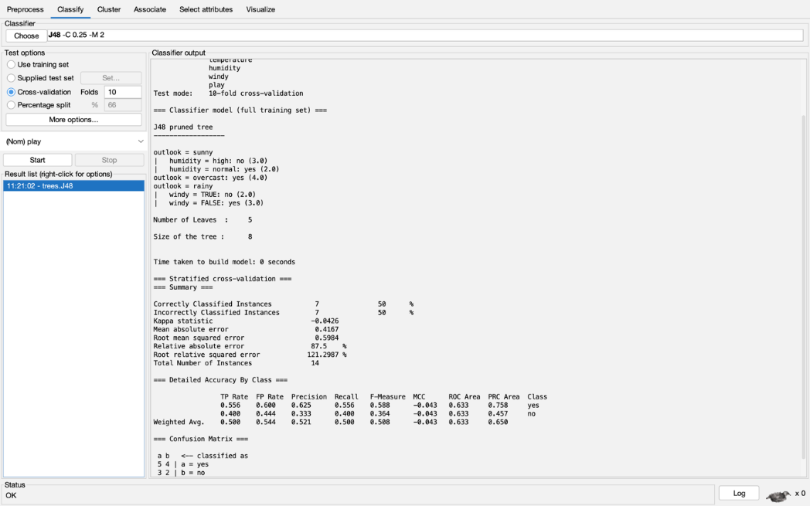

Figure 11: Output of J48 Algorithm

**Step 5: Visualize the Decision Tree**

1. Right-click on the result line in the "Result list" box.
2. Select "Visualize tree" from the context menu.
3. This will open a graphical representation of the decision tree generated by the algorithm.

### 

Figure 12: Visualize tree after J48 Algorithm

**Discussion:**

* **ID3 vs J48:** Both ID3 and J48 are decision tree algorithms, but J48 improves on ID3 by handling continuous attributes and performing pruning, which reduces the risk of overfitting. Additionally, cross-validation helps evaluate the model’s accuracy by testing it on multiple data splits.
* **Performance Evaluation:** By using 10-fold cross-validation, we can accurately assess the performance of both models. J48 tends to create a more compact and optimized tree due to its pruning feature.

**Conclusion:**

In this lab, we applied both the ID3 and J48 decision tree algorithms to classify a primary dataset. Using 10-fold cross-validation, we assessed the performance of each model and visualized the decision tree from J48. The J48 algorithm produced a more optimized and compact tree, making it better suited for real-world classification tasks compared to ID3.

**ST. XAVIER’S COLLEGE**

**Maitighar, Kathmandu**

**(Affiliated to Tribhuvan University)**



**LAB REPORT ON**

**DATA MINING AND DATA WAREHOUSING (IT 308)**

**SUBMITTED BY:** **SUBMITTED TO:**

**Name: Shashank Acharya Er. Anuj Shrestha**

**Faculty/Semester: BIM/8th (NEC Registration No.:5495)**

**Roll No.: 020BIM045 Lecturer,**

**Dept. of Computer Science**

# Lab Number: 5

**Title**: Naïve Bayes Classifier Implementation on a Primary Dataset.

**Objective**: To classify a primary dataset using the Naïve Bayes classifier and evaluate the performance of the model.

**IDE/Tools used**: Weka.

# Theory

### **Naïve Bayes Classifier:**

The **Naïve Bayes** classifier is a probabilistic model based on **Bayes' Theorem**, which calculates the **posterior probability** of a class given observed features. It assumes that the features (attributes) are conditionally independent, which is why it’s called "naïve."

**Bayes' Theorem:**

P(A∣B)=P(B∣A)⋅P(A)P(B)P(A|B) = \frac{P(B|A) \cdot P(A)}{P(B)}P(A∣B)=P(B)P(B∣A)⋅P(A)​

Where:

* **P(A|B)** is the **posterior probability** ofclass **A** given feature **B,**
* **P(B|A)** is the **likelihood** of feature **B** given class **A,**
* **P(A)** is the **prior probability** of class **A,**
* **P(B)** is the **prior probability** of feature **B.**

### **Types of Naïve Bayes Classifiers:**

* **Gaussian Naïve Bayes:** Used for continuous features assuming a **Gaussian (normal) distribution.**
* **Multinomial Naïve Bayes:** Used for discrete data, especially for **text classification** tasks like **spam detection.**
* **Bernoulli Naïve Bayes:** Works with **binary features** (0s and 1s), suitable for **binary data** classification.

### **Advantages of Naïve Bayes Classifier:**

1. **Simplicity:** Easy to implement and understand.
2. **Speed:** Fast training and prediction.
3. **Performance:** Works well with high-dimensional data (e.g., text classification).
4. **Scalability:** Efficient on large datasets.

### **Disadvantages of Naïve Bayes Classifier:**

1. **Feature Independence Assumption:** Assumes features are independent, which may not hold true in many real-world scenarios.
2. **Zero Probability:** If a feature value does not appear in the training set, it assigns zero probability; this can be handled using **Laplace smoothing**.

### **Applications of Naïve Bayes Classifier:**

* **Text Classification:** Spam filtering, sentiment analysis, document categorization.
* **Medical Diagnosis:** Predicting diseases from patient data.
* **Recommendation Systems:** Suggesting products based on user behavior.

**Implementation**

## Steps for using Naïve Bayes Classifier

### Step 1: Select the Appropriate Primary Dataset

The dataset should be loaded in **.arff** or **.csv** format. This dataset will contain the instances and attributes for classification.

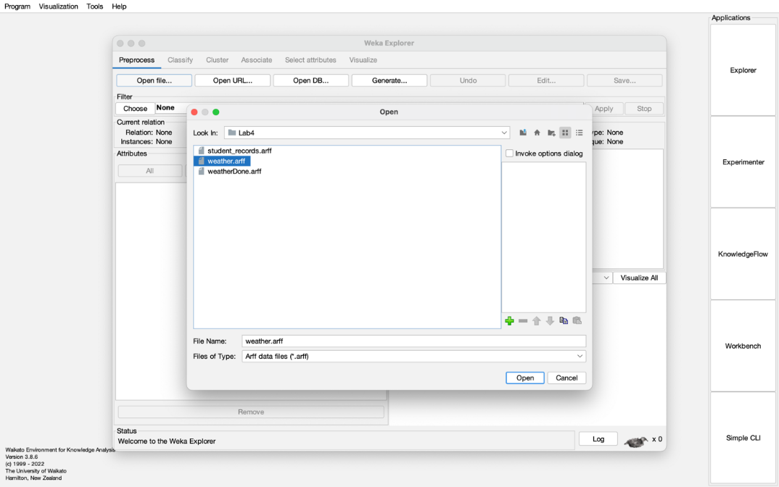

Figure 1: Selecting the Appropriate Primary Dataset

### Step 2: Loaded Dataset

Verify that the dataset is loaded correctly, ensuring all instances and attributes are available for classification.

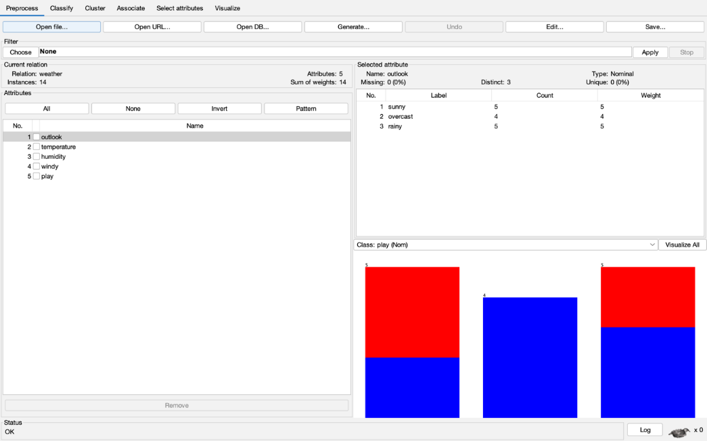

Figure 2: Loading the Nominal Dataset

### Step 3: Apply the Naïve Bayes Filter

* In WEKA, navigate to the Classify tab.
* Select the Naïve Bayes algorithm from the bayes category.

**Naïve Bayes Algorithm:**

* The Naïve Bayes classifier calculates the probability of each class (e.g., PlayTennis as Yes/No) based on the conditional probabilities of the features (e.g., Outlook, Temperature, Humidity, Wind).
* It applies Bayes' theorem to estimate the posterior probability and classifies the instances accordingly.

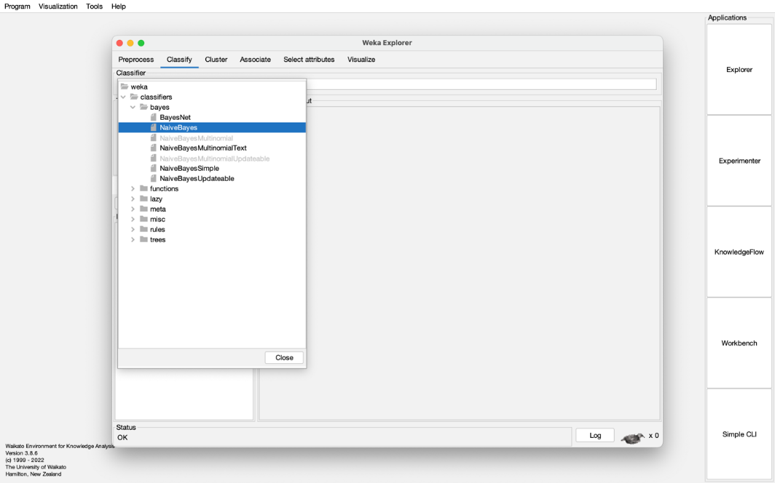

Figure 3: Choose Naïve Bayes Algorithm

### Step 4: Configure and Run the Naïve Bayes Algorithm Filter

* Set the model evaluation method, such as cross-validation (usually 10-fold), to assess the model’s performance.
* Click "Start" to run the Naïve Bayes algorithm and generate the classification results.

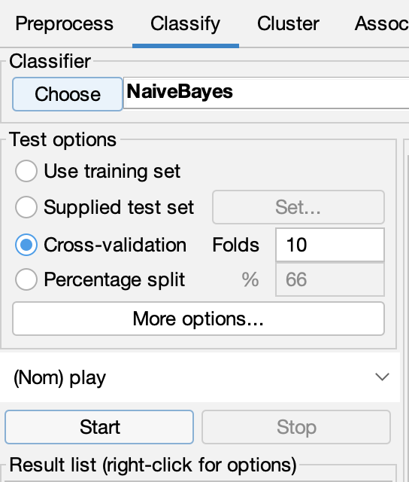

Figure 4: Configure Naïve Bayes classifier

### Step 5: Classification Details (Resultant)

* Examine the results in the Classifier output section, which includes key metrics like accuracy, precision, recall, and the confusion matrix to assess the model's performance.
* If necessary, adjust the model configuration (e.g., by enabling Laplace smoothing) and rerun the model to improve results.

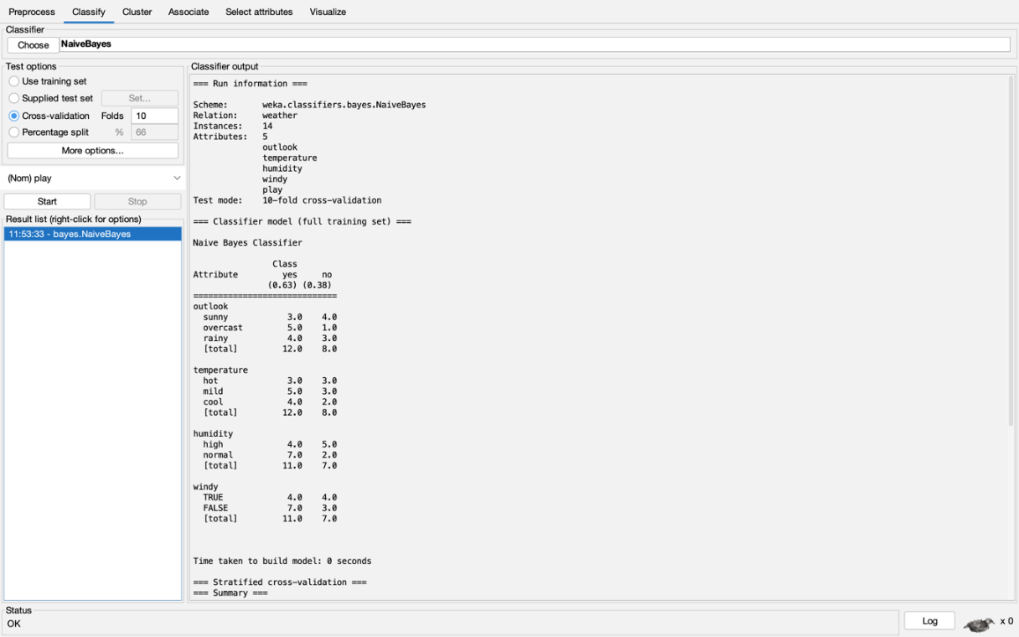

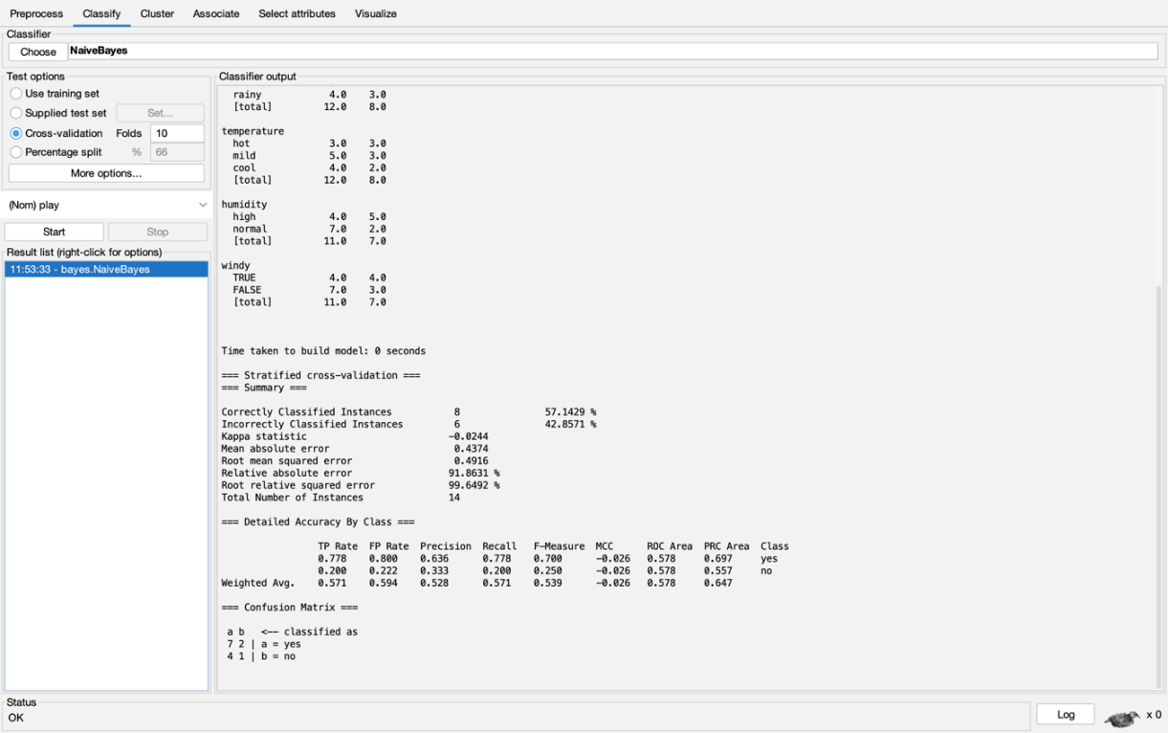

Figure 5: Output of Naïve Bayes Classifier

After running the classifier, WEKA will display various evaluation metrics, including accuracy, precision, recall, and the confusion matrix, to show how well the model performed in classifying the dataset.

By following these steps, you can effectively use the Naïve Bayes Classifier in WEKA to classify your dataset and analyze the resulting performance metrics and decision tree.

### Step 6: Evaluation of Output

When evaluating the performance of a classification model like the Naïve Bayes classifier, several key metrics are used to understand how well the model is performing. The most commonly used metrics are Precision, Recall, and F1-Score. Here is an explanation of each metric:

**Precision**

Precision is the ratio of correctly predicted positive observations to the total number of predicted positive observations. It answers the question: *What proportion of predicted positives is actually correct?*

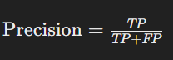

Where:

* TP (True Positives) are the instances correctly predicted as positive.
* FP (False Positives) are the instances incorrectly predicted as positive.

Interpretation: High precision indicates that the classifier makes few mistakes when it predicts a positive result.

**Recall**

Recall (also known as Sensitivity or True Positive Rate) is the ratio of correctly predicted positive observations to all actual positive observations. It answers the question: *What proportion of actual positives is correctly identified by the model?*

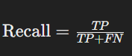

Where:

* TP (True Positives) are the instances correctly predicted as positive.
* FN (False Negatives) are the instances incorrectly predicted as negative.

Interpretation: High recall indicates that the classifier captures most of the positive instances.

**F1-Score**

The **F1-Score** is the harmonic mean of **Precision** and **Recall**, providing a single metric that balances both. It’s particularly useful when you need to consider both precision and recall, especially in cases with uneven class distribution.

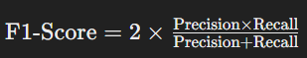

**Interpretation:** The F1-Score ranges from **0 to 1**, where **1** represents perfect precision and recall. It’s a valuable metric when you're working with an imbalanced dataset, as it ensures that both false positives and false negatives are minimized.

**Visalization of Results:**

The output from the Naïve Bayes classifier includes several key metrics to evaluate the model's performance:

* **Accuracy:** The percentage of correctly classified instances.
* **Precision and Recall:** These metrics assess the model’s performance on positive and negative classes, indicating how well the model identifies each class.
* **Confusion Matrix:** A table displaying the counts of true positives, false positives, true negatives, and false negatives, helping to visualize the classification results.

**Discussion:**

The Naïve Bayes classifier is a simple but effective algorithm for classification. While it assumes that features are independent, it still performs well in many real-world applications, like text classification and spam filtering. In this lab, we used the Gaussian Naïve Bayes classifier, which is ideal for datasets with continuous attributes, and the Multinomial Naïve Bayes classifier, which is well-suited for text-based tasks.

**Conclusion:**

In this lab, we applied the Naïve Bayes classifier to a primary dataset and evaluated the model's accuracy using cross-validation. The classifier proved efficient, especially with high-dimensional datasets. Despite its simplicity, it remains a powerful and reliable tool for classification tasks.

**ST. XAVIER’S COLLEGE**

**Maitighar, Kathmandu**

**(Affiliated to Tribhuvan University)**



**LAB REPORT ON**

**DATA MINING AND DATA WAREHOUSING (IT 308)**

**SUBMITTED BY:** **SUBMITTED TO:**

**Name: Shashank Acharya Er. Anuj Shrestha**

**Faculty/Semester: BIM/8th (NEC Registration No.:5495)**

**Roll No.: 020BIM045 Lecturer,**

**Dept. of Computer Science**

# Lab Number: 6

**Title**: Multilayer Perceptron Visualization

**Objective**: To illustrate and visualize a **Multilayer Perceptron (MLP)** network, demonstrating the architecture and functioning of its layers.

**Tools used**: Weka.

**Theory:**

A Multilayer Perceptron (MLP) is a form of feedforward artificial neural network (ANN) comprising three main types of layers:

1. **Input Layer**
   * This layer receives the dataset's input features. Each neuron in this layer corresponds to one attribute or variable in the input data.
2. **Hidden Layer(s)**
   * These intermediate layers process the input using weighted connections and activation functions. An MLP can have one or more hidden layers. The number of layers and neurons determines the network's complexity.
3. **Output Layer**
   * This layer generates the final output (such as class predictions or continuous values). For classification tasks, it contains as many neurons as there are classes, while for regression, it typically contains one neuron.

**How MLP Functions**

* **Forward Propagation**During this phase, data moves sequentially from the input layer through the hidden layers to the output. Each neuron computes a weighted sum of its inputs, applies an activation function, and sends the result to the next layer.
* **Activation Functions**These introduce non-linearity, allowing the network to capture complex patterns. Common types include:
  + ReLU (Rectified Linear Unit): f(x)=max⁡(0,x)f(x) = \max(0, x)f(x)=max(0,x)
  + Sigmoid: f(x)=11+e−xf(x) = \frac{1}{1 + e^{-x}}f(x)=1+e−x1​
  + Tanh: f(x)=tanh⁡(x)f(x) = \tanh(x)f(x)=tanh(x)
* **Loss Function**The loss function evaluates the difference between the predicted and actual outputs. Cross-entropy is commonly used for classification, while Mean Squared Error (MSE) is typical for regression.
* **Backpropagation**This is the learning mechanism of MLP. After computing the output and loss, the error is propagated backward through the network. During this process, weights are updated using optimization techniques like gradient descent to reduce the error.

**MLP Architecture Representation**

* Neurons are shown as circles in each layer.
* Layers are arranged sequentially (input → hidden → output), with arrows indicating data flow.
* Connections/Weights are represented by lines linking neurons between layers, which are adjusted during training.

**Applications of MLP**

* Classification: Suitable for tasks like image classification, speech detection, and churn prediction.
* Regression: Useful for estimating continuous values such as housing prices or stock market trends.

**Implementing MLP in WEKA: Step-by-Step**

1. Load the Dataset
   * Open WEKA and import your dataset (in .arff or .csv format).
2. Choose the MLP Classifier
   * Go to the Classify tab.
   * Select Multilayer Perceptron under the functions section.
3. Configure the MLP Parameters
   * Set the number of hidden layers and neurons.
   * Adjust settings such as learning rate, momentum, and the number of epochs (training cycles).
4. Train and Evaluate the Model
   * Use techniques like 10-fold cross-validation to assess performance.
   * Click Start to initiate training and view evaluation metrics like accuracy, precision, and recall.
5. Visualize the Network (Optional)
   * You can visualize the structure of the MLP to better understand its design and connectivity.

**Implementation**

## Steps for using Multilayer Perceptron Visualization

**Step 1: Choose a Suitable Primary Dataset**

Choosing the right primary dataset is a critical first step, as it ensures compatibility and relevance for the analysis. In WEKA, datasets must be in the .arff (Attribute-Relation File Format), which contains both the data itself and important metadata, including attribute names and class labels. This structured format is essential for WEKA to accurately interpret the dataset and apply machine learning algorithms effectively.

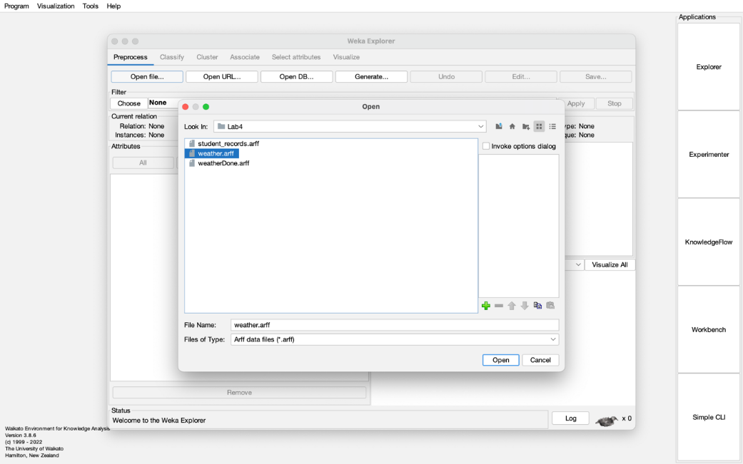

Figure 1: Selecting the Appropriate Primary Dataset

**Step 2: Load the Dataset**

After importing the dataset into WEKA, it's essential to confirm that it has been loaded properly. This step involves checking that all attributes and instances are present as expected, ensuring the dataset is complete and free from any loading errors or formatting issues.

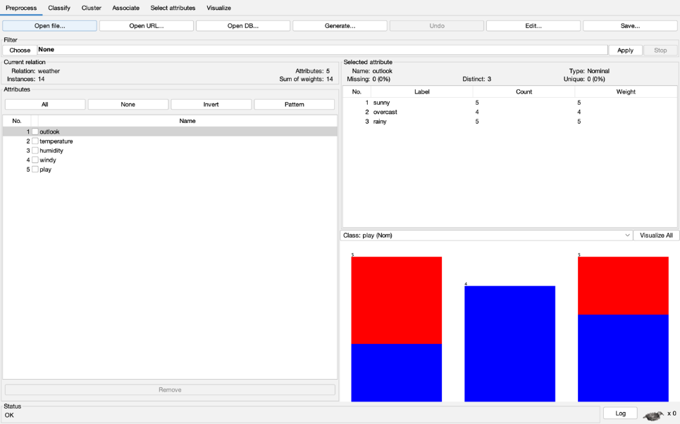

Figure 2: Loading the Nominal Dataset

**Step 3: Select the Multilayer Perceptron**

To use the Multilayer Perceptron (MLP) for classification or regression tasks in WEKA, begin by choosing it from the list of available classifiers. MLP is a form of artificial neural network composed of multiple layers of interconnected nodes, enabling it to learn complex patterns in data.

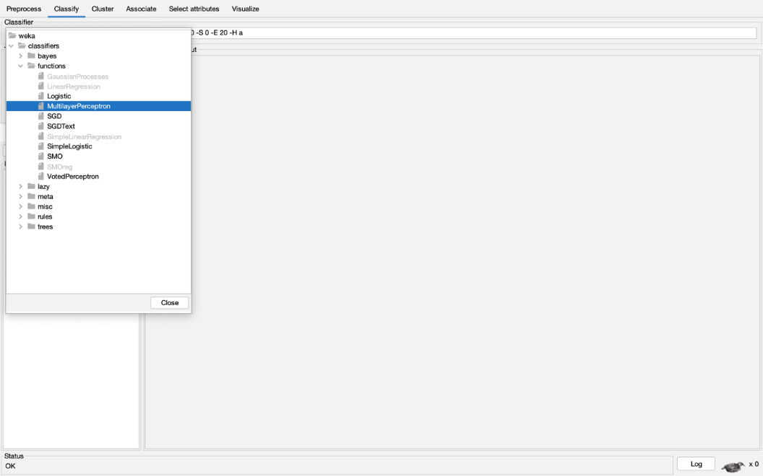

Figure 3: Choose Multiplayer Perceptron

**Step 4: Enable Visualization for the Multilayer Perceptron**

By default, WEKA may have the neural network visualization feature disabled. To view the architecture of the neural network after training, you need to enable this setting. Go to the configuration options for the Multilayer Perceptron and set the GUI option to true to activate graphical visualization of the model structure.

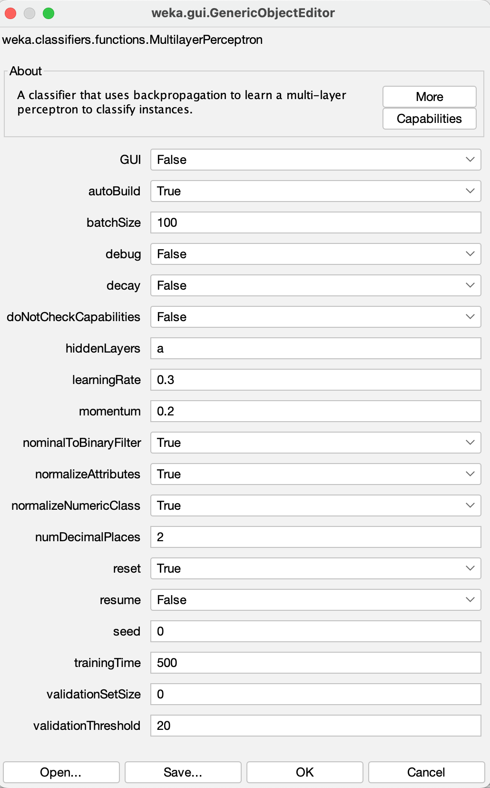 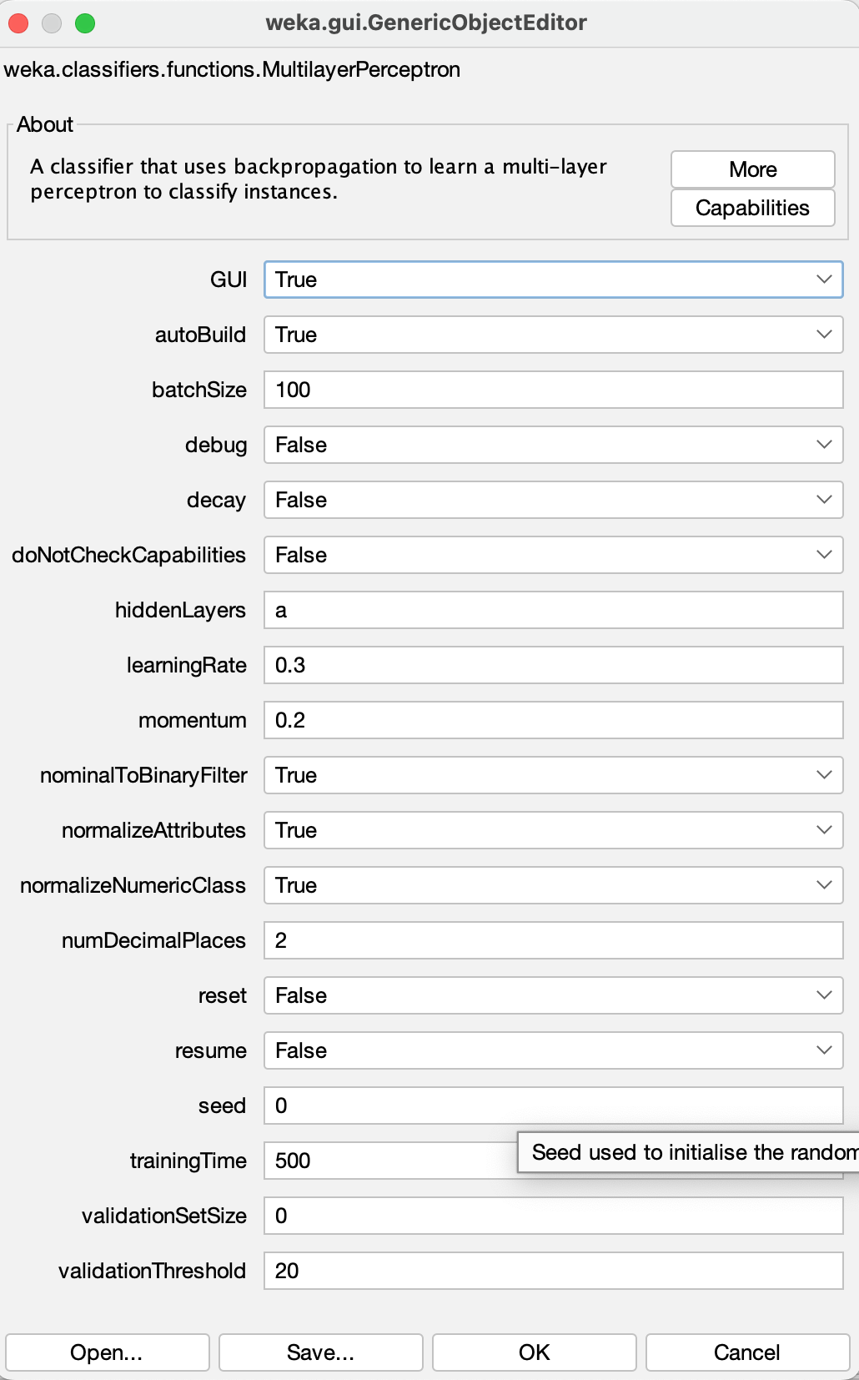

Figure 4: Configure Multilayer Perceptron Function

**Step 5: Run the Multilayer Perceptron**

Once you've configured the MLP by setting parameters such as learning rate, number of hidden layers, and activation functions, you can start the training process. After execution, WEKA will display detailed results, including key performance metrics likeaccuracy, precision, recall, and a confusion matrix—helping you assess how well the model performs on the dataset.

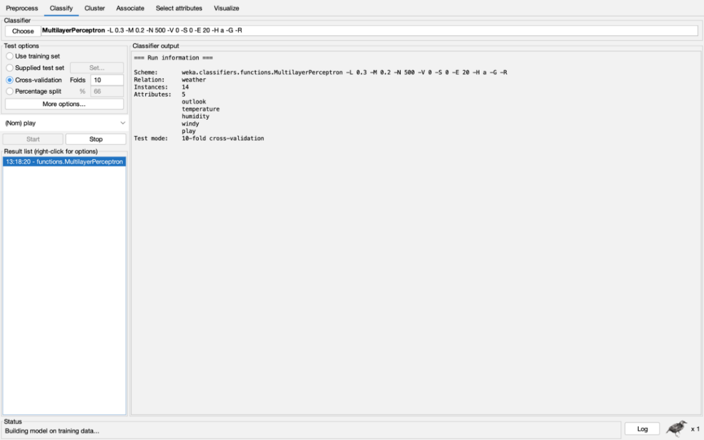

Figure 5: Output of the function

### Step 6: Neural Network Visualization

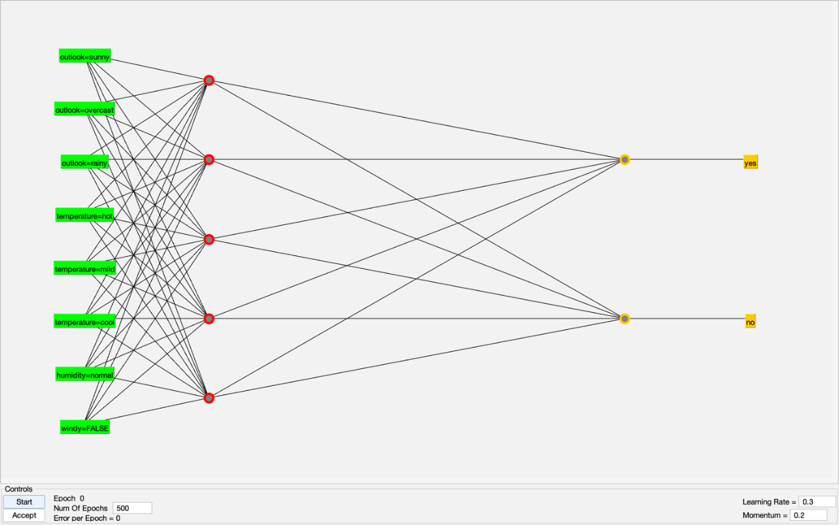

Figure 6: Neural Network Visualization

### Running the Multilayer Perceptron (MLP)

### Network Architecture:

### Input Layer: Contains 4 neurons corresponding to the input features — Outlook, Temperature, Humidity, and Wind.

### Hidden Layer: Comprises 5 neurons using an activation function (e.g., sigmoid) to process the input.

### Output Layer: Has 2 neurons representing the binary output classes for the PlayTennis decision (Yes or No).

### Training Process:

### Forward Propagation: The input data passes through the network layers sequentially.

### Backpropagation: The model adjusts its weights to reduce prediction errors.

### Cross-Validation: The dataset is split into subsets to evaluate model performance more reliably and avoid overfitting.

### Output and Evaluation:

### Accuracy: Indicates the percentage of instances that the model classified correctly.

### Confusion Matrix: Summarizes prediction results with counts of true positives, false positives, true negatives, and false negatives.

### Network Visualization: Graphically represents the MLP structure, showing the neurons and connections across layers, aiding in understanding data flow and model behavior.

### This process is essential for analyzing how the model interprets and processes information throughout its layers, leading to better evaluation of performance.

### Discussion:

### MLP models are highly capable for both classification and regression tasks. Although they can be computationally intensive compared to simpler algorithms, their strength lies in their ability to learn and model intricate data patterns. The backpropagation mechanism refines the model by adjusting weights to minimize error, making MLPs effective for real-world applications like image recognition, fraud detection, and predictive modeling. WEKA’s intuitive interface makes it easier to construct, train, and visualize MLP networks, making them more accessible to users for educational and practical purposes.

### Conclusion:

### In this lab session, we examined the design and operation of a Multilayer Perceptron (MLP) network. We utilized WEKA to build and visualize the neural network and applied it to classification and regression problems. By fine-tuning parameters such as the number of hidden layers, neurons, and learning rates, MLP models can be customized to achieve strong performance across various datasets, offering meaningful insights into complex data relationships.

**ST. XAVIER’S COLLEGE**

**Maitighar, Kathmandu**

**(Affiliated to Tribhuvan University)**



**LAB REPORT ON**

**DATA MINING AND DATA WAREHOUSING (IT 308)**

**SUBMITTED BY:** **SUBMITTED TO:**

**Name: Shashank Acharya Er. Anuj Shrestha**

**Faculty/Semester: BIM/8th (NEC Registration No.:5495)**

**Roll No.: 020BIM045s Lecturer,**

**Dept. of Computer Science**

# Lab Number: 7

**Title**: Generating Association Rules using Apriori Algorithm

**Objective**: The purpose of this lab is to apply the Apriori algorithm to a selected primary dataset, ensuring that appropriate preprocessing is performed if required. The aim is to discover association rules using a minimum support of 0.2 and a minimum confidence of 0.7. This exercise is designed to help us grasp the methodology behind association rule mining and analyze the generated rules to derive meaningful and practical insights.

**Tools used**: Weka.

## Theory

Association rule mining is a key data mining technique used to identify meaningful relationships, patterns, or correlations within large sets of transactional data. It's widely applied in industries such as retail, healthcare, and web analytics to uncover hidden patterns.

## Association Rules

Association rules are expressed in the form:

A ⟹ B, where:

* A (Antecedent): The item or set of items found in transactions.
* B (Consequent): The item(s) likely to occur when A is present.

Two primary metrics are used to evaluate these rules:

* Support: Indicates how often both A and B occur together in the dataset.
* Confidence: Reflects the probability that B appears when A is present.

For instance, in a retail scenario, if customers often purchase *milk* and *bread* together, the rule Milk ⟹ Bread implies that people who buy milk are also likely to buy bread. This can inform decisions like shelf placement or promotional offers.

## Apriori Algorithm

The Apriori algorithm is a widely adopted approach for discovering frequent itemsets and deriving association rules. It is built on the downward closure principle, which states:

* If an itemset is frequent, all of its subsets must also be frequent.
* Conversely, if an itemset is infrequent, all supersets will be infrequent too.

Steps in the Apriori Algorithm:

1. **Set Minimum Thresholds:**
   * Define minimum values for support and confidence to guide rule selection.
2. **Generate Frequent Itemsets:**
   * Identify frequent 1-itemsets that meet the support threshold.
   * Combine them to form 2-itemsets, then filter.
   * Repeat the process for larger itemsets until no new frequent itemsets are found.
3. **Generate Association Rules:**
   * Derive rules from the frequent itemsets (A ⟹ B).
   * Calculate the confidence for each rule and retain only those meeting the threshold.
4. **Prune Rules:**
   * Eliminate irrelevant or redundant rules using the downward closure principle to improve efficiency.

## Advantages of the Apriori Algorithm:

1. Easy to Understand: The algorithm is conceptually simple and straightforward to implement.
2. Reduces Search Space: Prunes unnecessary itemsets using the downward closure property.
3. Broad Applicability: Suitable for many domains like market analysis, web usage mining, and biological data mining.

## Limitations:

1. Computationally Intensive: Requires multiple passes over the dataset, making it slower on large datasets.
2. High Memory Usage: Can be resource-heavy due to the need to store numerous candidate itemsets.
3. Overgeneration of Rules: May produce a large volume of rules, many of which are irrelevant or redundant.

## Real-World Applications:

1. Retail and Market Basket Analysis: Reveals buying patterns that support better shelf arrangement and cross-selling.
2. Healthcare Analytics: Detects associations between symptoms and diseases for improved diagnostics.
3. Fraud Detection: Identifies unusual activity in financial transactions to flag potential fraud.

By using the Apriori algorithm, we can extract meaningful insights from large datasets, enabling data-driven strategies and smarter decision-making across various fields.

## Implementation

## Steps for using Apriori Algorithm

#### **Step 1: Selecting the Primary Dataset**

Begin by selecting a suitable dataset that is properly structured for analysis. WEKA specifically requires the data to be in the .arff (Attribute-Relation File Format), which contains both the actual data and descriptive metadata. It's important to verify that the dataset is appropriate for association rule mining to ensure meaningful and accurate outcomes.

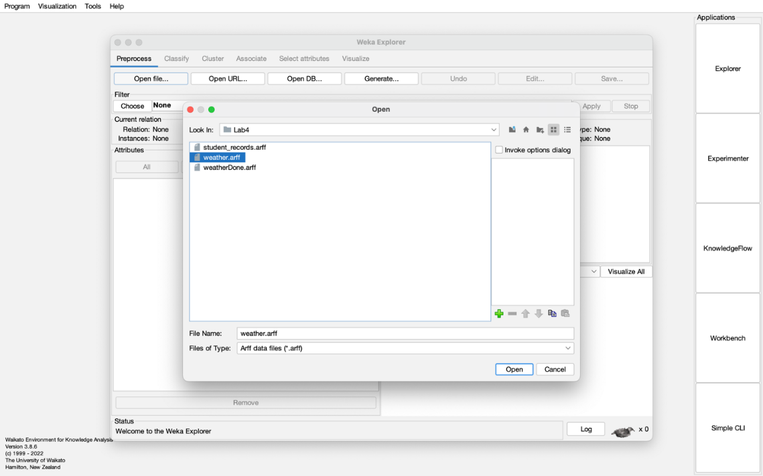

Figure 1: Selecting the Appropriate Primary Dataset

### Step 2: Loading the Dataset

### After selecting the dataset, it should be imported into WEKA. It's important to check the dataset post-loading to ensure that all attributes and records have been accurately loaded. This verification step helps avoid potential issues during the association rule mining process.

### 

Figure 2: Loading the Nominal Dataset

**Step 3: Selecting the Apriori Algorithm**

To start the association rule mining process:

* Go to the "Associate" tab in WEKA, where you'll find a list of available algorithms.
* Choose "Apriori," a popular algorithm for mining frequent itemsets and generating association rules from transactional data.

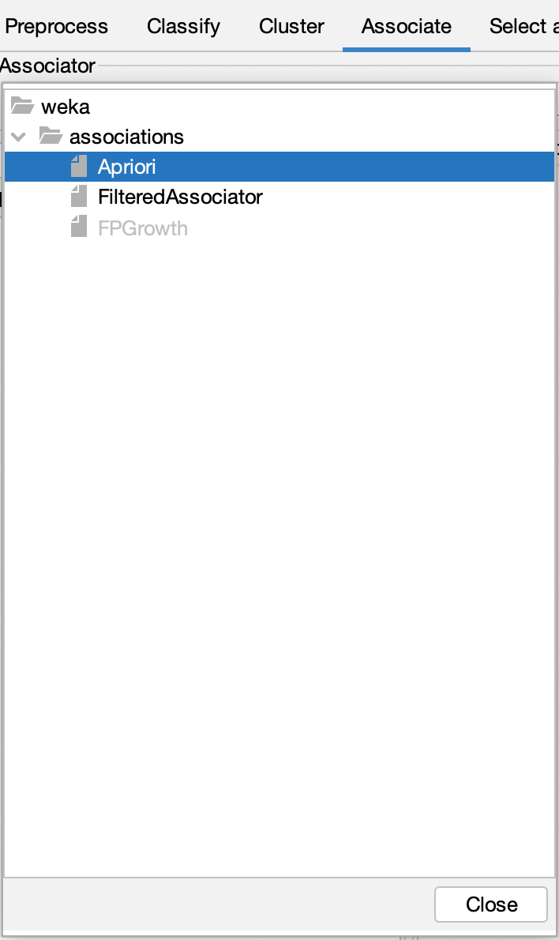

Figure 3: Choose Apriori Algorithm

**Step 4: Configuring the Apriori Algorithm**

* Setting Minimum Support: Define the minimum support threshold, which specifies how often an itemset must appear in the dataset to be considered frequent. In this case, the support is set to 0.2, meaning an itemset must appear in at least 20% of transactions to qualify.
* Setting Minimum Confidence: Set the confidence threshold to ensure that only strong, reliable rules are generated. For this experiment, a confidence level of 0.7 (or 70%) is chosen, ensuring that only robust rules are considered.

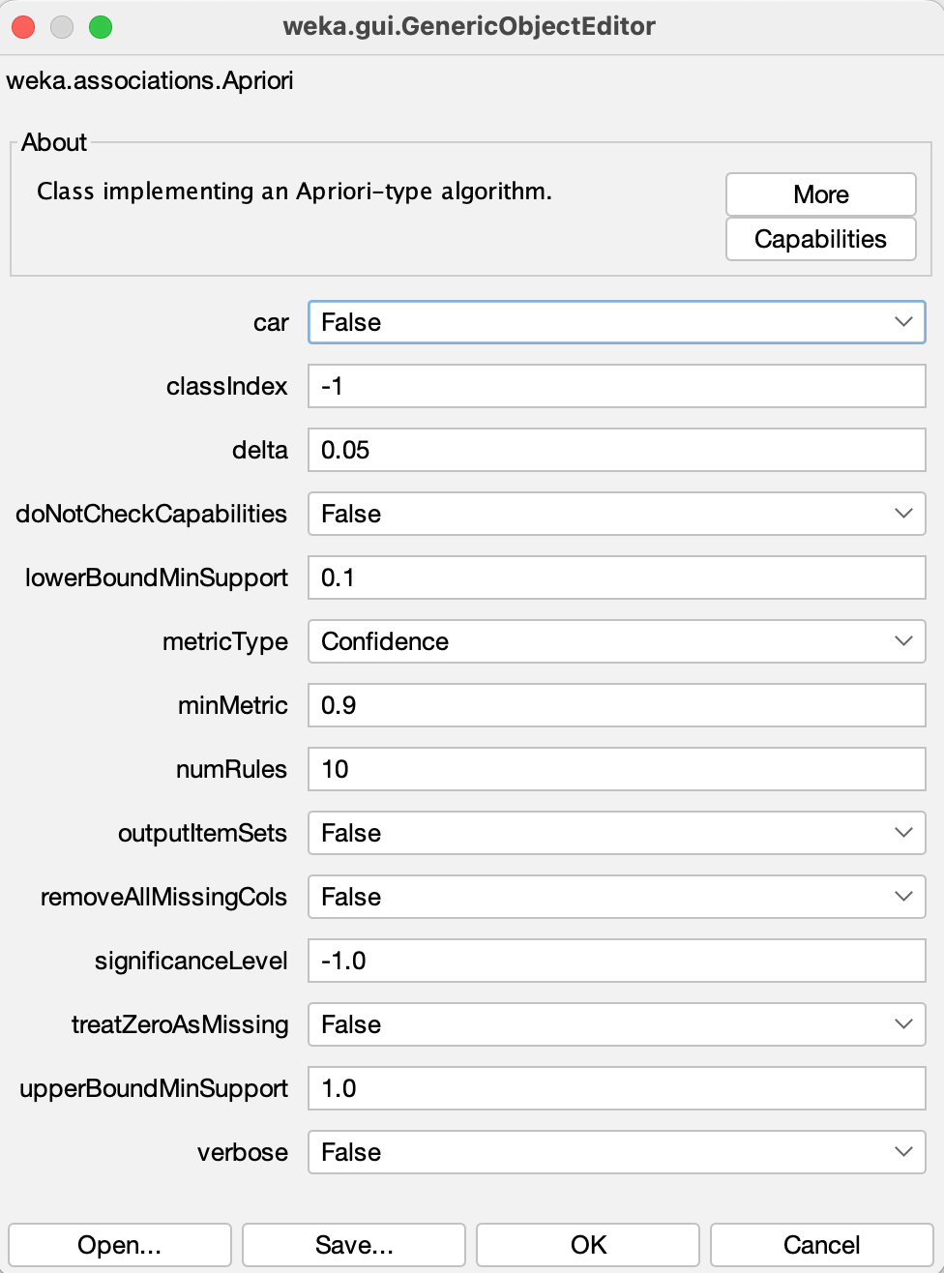 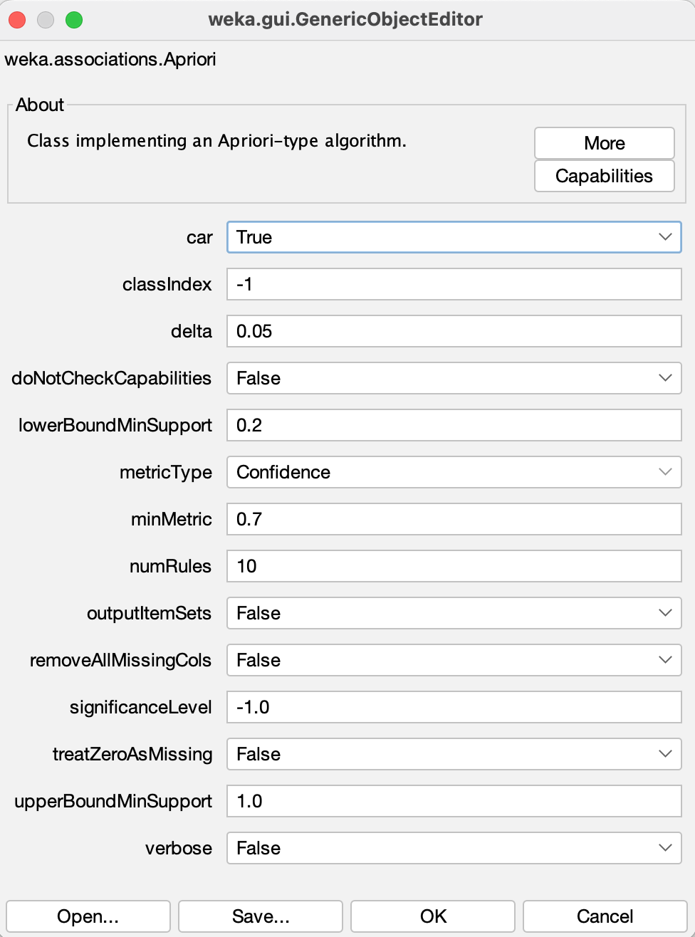

Figure 4: Configure Apriori Algorithm

**Step 5: Running Apriori**

* Click the "Start" button in WEKA to initiate the Apriori algorithm.
* The algorithm processes the dataset according to the defined minimum support (0.2) and confidence (0.7) thresholds.
* WEKA will then generate frequent itemsets and association rules, which will be displayed in the output window.
* The generated rules can be analyzed to identify meaningful patterns and relationships within the data.

This step concludes the association rule mining process, offering valuable insights derived from the dataset analysis.

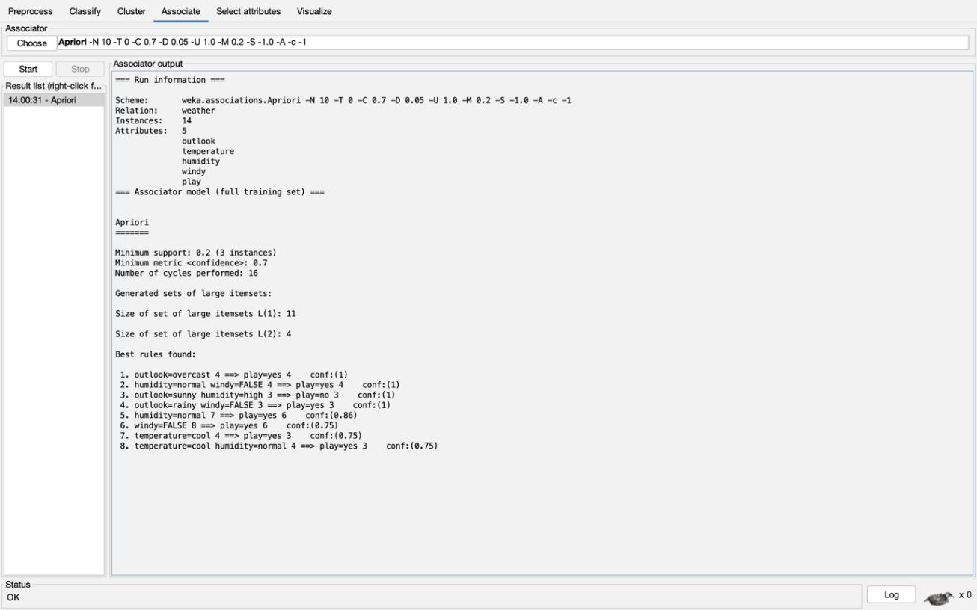

Figure 5: Output of Apriori Algorithm

**Discussion:**The application of the Apriori algorithm allowed us to identify frequent itemsets and extract significant association rules related to weather conditions and their effect on playing tennis. By setting the minimum support to 0.2 and the minimum confidence to 0.7, only the most relevant and statistically meaningful patterns were considered. The resulting rules provide valuable insights into which weather conditions are most likely to either support or prevent a tennis game. These insights can aid in better decision-making when scheduling sports activities based on weather forecasts.

**Conclusion:**In this lab, we successfully applied the Apriori algorithm to the Tennis Dataset using WEKA. By carefully selecting the appropriate support and confidence thresholds, we uncovered meaningful associations between various weather conditions and the likelihood of playing tennis. This experiment highlighted the effectiveness of the Apriori algorithm in discovering hidden patterns within data, emphasizing its significance in data mining and decision-making processes.

**ST. XAVIER’S COLLEGE**

**Maitighar, Kathmandu**

**(Affiliated to Tribhuvan University)**



**LAB REPORT ON**

**DATA MINING AND DATA WAREHOUSING (IT 308)**

**SUBMITTED BY:** **SUBMITTED TO:**

**Name: Shashank Acharya Er. Anuj Shrestha**

**Faculty/Semester: BIM/8th (NEC Registration No.:5495)**

**Roll No.: 020BIM045 s Lecturer,**

**Dept. of Computer Science**

# Lab Number: 8

**Title**: Generating Association Rules using FP-Growth Algorithm

**Objective**: The purpose of this report is to apply the **FP-Growth algorithm** for **association rule mining** on a primary dataset.

**Tools used**: Weka.

Theory:Association rule mining is a technique in data mining used to uncover relationships or patterns between items in large datasets. It is often applied in areas such as market basket analysis to discover correlations among items. Association rules are typically written as:

A ⟹ B

Where:

* A (antecedent) represents an itemset, and B (consequent) represents another itemset.
* The rule suggests that if A occurs, B is likely to occur with a certain probability.

Key metrics for evaluating association rules include:

* Support, which measures how frequently both A and B appear together in the dataset.
* Confidence, which indicates the likelihood of B occurring when A occurs.

The FPGrowth algorithm is an efficient method for mining frequent itemsets and generating association rules, providing a faster alternative to the Apriori algorithm. Unlike Apriori, FPGrowth does not require generating candidate itemsets and instead uses a Frequent Pattern Tree (FP-Tree) to compress the dataset.

## FPGrowth Algorithm:

The FP-Tree is a compressed representation of the dataset that preserves itemset order. It groups transactions with common prefixes into shared paths, making the dataset more manageable for mining frequent itemsets.

## Steps in FPGrowth:

1. **Construct the FP-Tree:**
   * Perform a single scan of the dataset to determine the frequency of each item and eliminate those below the minimum support threshold.
   * Sort the remaining items by frequency in descending order.
   * Build the FP-Tree by adding transactions in a way that places frequent items at the top and shares paths for common prefixes.
2. **Recursive Mining:**
   * After the FP-Tree is constructed, the algorithm mines frequent itemsets starting from the less frequent items at the bottom.
   * It recursively explores conditional sub-trees, reducing the dataset size at each step, which helps avoid multiple scans and improves efficiency.
3. **Generate Association Rules:**
   * After identifying frequent itemsets, the algorithm computes support and confidence to generate association rules.
   * Rules that meet the minimum confidence threshold are considered valid.

## Advantages of FPGrowth:

1. Efficiency: FPGrowth is faster than Apriori because it avoids candidate generation and requires fewer dataset scans.
2. Compact Data Representation: The FP-Tree compresses the dataset, saving memory space.
3. Scalability: FPGrowth is highly suitable for large datasets and high-dimensional data.

## Disadvantages of FPGrowth:

1. Complexity: Building the FP-Tree can be complicated, especially with large datasets and many frequent items.
2. FP-Tree Size: While the FP-Tree is compact, it can still become large if there are many frequent items.

**Implementation**

## Steps for using FP-Growth Algorithm

### Step 1: Select the Appropriate Primary Dataset

The first step when using Weka is to choose an appropriate dataset. It is important to ensure that the dataset is relevant and properly formatted. Weka requires datasets in the .arff (Attribute-Relation File Format), which contains both the raw data and its metadata.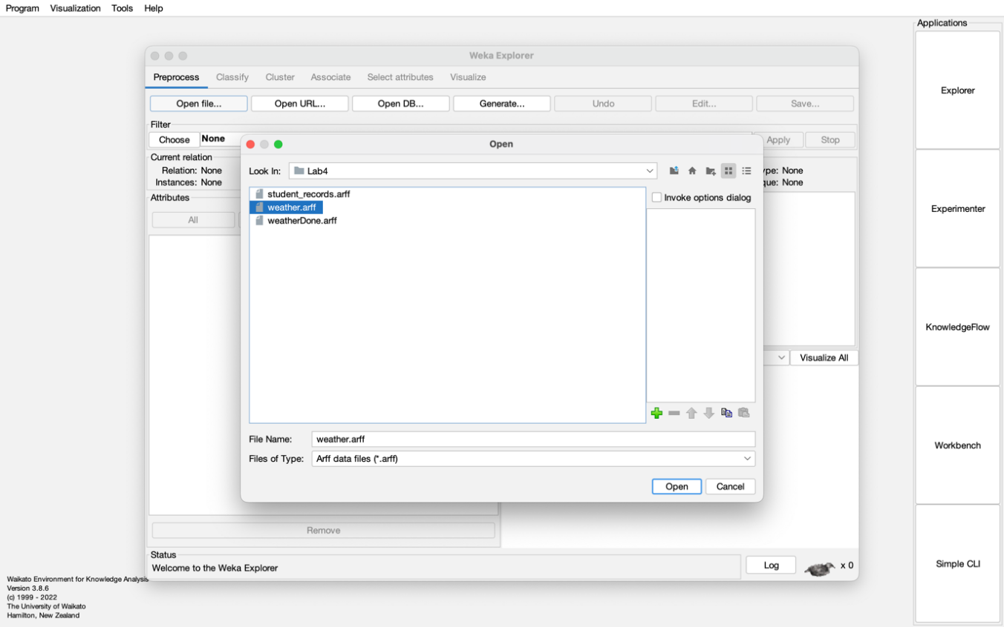

Figure 1: Selecting the Appropriate Primary Dataset

**Step 2: Loading the Dataset**

After selecting the dataset, the next step is to load it into Weka. It’s essential to verify that the data has been loaded correctly to ensure all attributes and instances are present, and that the dataset file is intact without any issues.

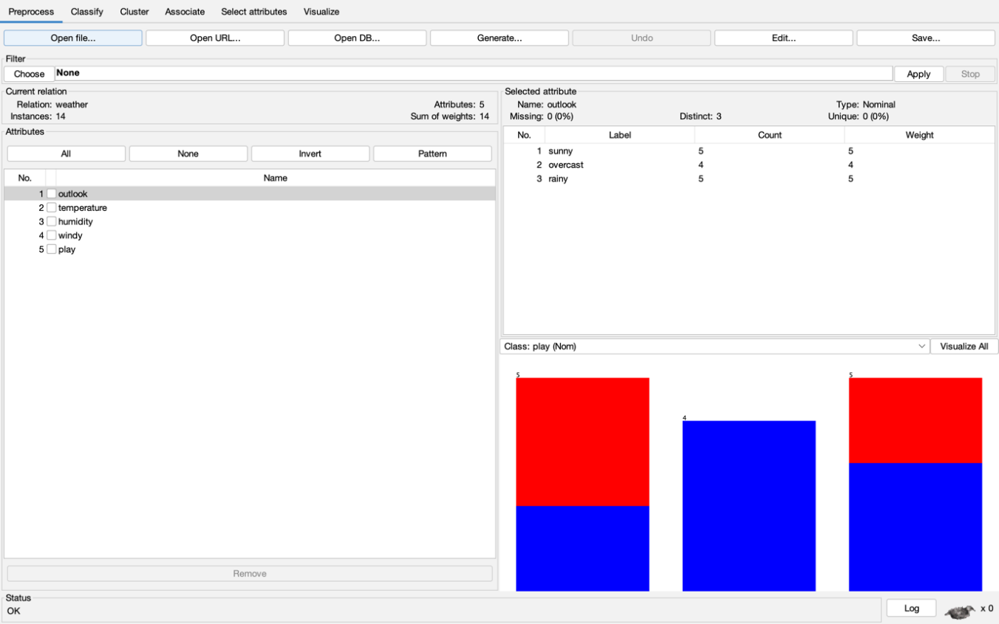

Figure 2: Loading the Nominal Dataset

**Step 3: Selecting the FP-Growth Algorithm**

To perform association rule mining using the FP-Growth algorithm:

* Go to the "Associate" tab in Weka.
* From the list of available algorithms, choose FP-Growth.
* If FP-Growth is not enabled, check that the dataset is in the correct format (either binary or nominal) and reload it if necessary.

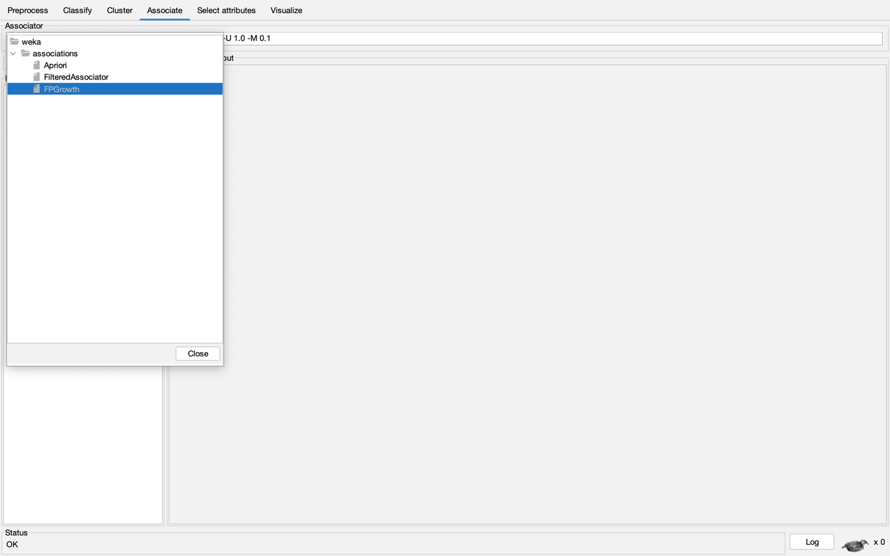

Figure 3: Choose FP Growth

**Step 4: Configuring FP-Growth**

In the FP-Growth configuration window:

* Set the Minimum Support: Define the minimum frequency at which an itemset must appear to be considered frequent. In this lab, set the support to 0.2 (20%).
* Set the Minimum Metric: This metric usually defines the minimum confidence required for the association rules. A metric value of 0.7 ensures that only rules with at least 70% confidence will be considered.

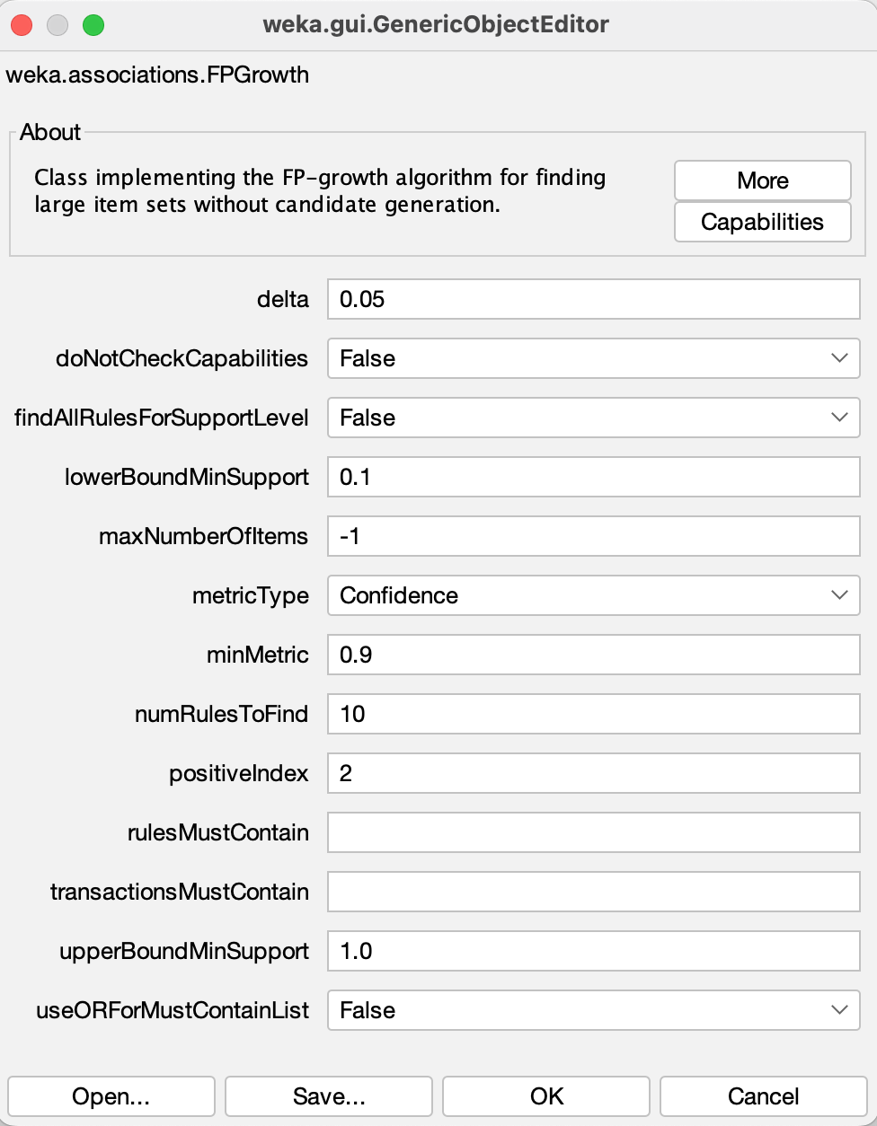 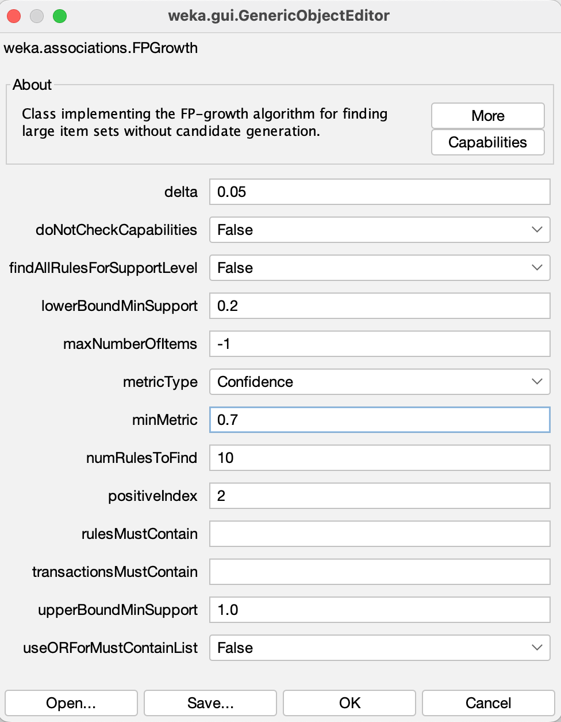

Figure 4: Configure FP Growth

### Discussion:

The FP-Growth algorithm was applied to the Tennis dataset to find association rules that link weather conditions with the likelihood of playing tennis. By setting a minimum support of 0.2 and minimum confidence of 0.7, we ensured that only significant and reliable patterns were found. FP-Growth was chosen over Apriori due to its superior efficiency in handling datasets with large numbers of potential itemsets.

### Conclusion:

In this lab, we successfully used the FP-Growth algorithm to generate association rules from the Tennis dataset, revealing valuable patterns about the relationship between weather conditions and the likelihood of playing tennis. The algorithm’s ability to mine frequent itemsets efficiently, without generating unnecessary candidates, made it well-suited for this task, especially when dealing with larger datasets.

**ST. XAVIER’S COLLEGE**

**Maitighar, Kathmandu**

**(Affiliated to Tribhuvan University)**



**LAB REPORT ON**

**DATA MINING AND DATA WAREHOUSING (IT 308)**

**SUBMITTED BY:** **SUBMITTED TO:**

**Name: Shashank Acharya Er. Anuj Shrestha**

**Faculty/Semester: BIM/8th (NEC Registration No.:5495)**

**Roll No.: 020BIM045 Lecturer,**

**Dept. of Computer Science**

# Lab Number: 9

**Title**: K-Means Clustering with Visualization

**Objective**: The goal of this experiment is to apply **K-means clustering** to a dataset, setting **K=2**, and visualize the data both **before and after clustering**. This helps in understanding how data points are grouped and the characteristics of the formed clusters.

**Tools used**: Weka.

# Theory:

# Clustering is a data mining and machine learning technique used to group similar objects together based on their features. Unlike classification, clustering does not rely on predefined labels. Instead, it identifies hidden patterns in the data, making it valuable for exploratory analysis, pattern detection, and feature engineering.

# K-Means is one of the most commonly used clustering algorithms. It divides a dataset into K distinct, non-overlapping clusters based on the similarities between the data points. The aim is to minimize the variance within each cluster while maximizing the differences between clusters.

## **Steps in K-means Algorithm:**

# Initialization

# Choose the number of clusters (K) (e.g., K=2).

# Randomly select K initial centroids for the clusters.

# Assignment

# Assign each data point to the nearest centroid using a distance measure (usually Euclidean distance).

#### **Update**

#### Update the centroid of each cluster by calculating the mean of all data points assigned to that clusster.

#### **Iteration**

#### Repeat the assignment and update steps until the centroids no longer change significantly, indicating the algorithm has converged.

#### **Final Result**

#### The dataset is divided into **K** clusters, with each point assigned to its nearest centroid.

#### **Advantages of K-Means**

* Simple to understand and implement.
* Computationally efficient, especially for large datasets with a small number of clusters.

#### **Limitations of K-Means**

* The number of clusters (**K**) must be predetermined, which can be challenging without prior knowledge.
* The algorithm is sensitive to the initial placement of centroids, which means different initializations can lead to different results.
* It assumes that clusters are spherical and of similar sizes, which may not always reflect the true structure of the data.

**Implementation**

## Steps for using K-means Algorithm

**Step 1: Selecting the Primary Dataset**

The first step is to choose a relevant dataset in the correct format. Weka supports the .arff (Attribute-Relation File Format), which includes both the data and its metadata. Ensuring the dataset is properly formatted is crucial for accurate clustering.

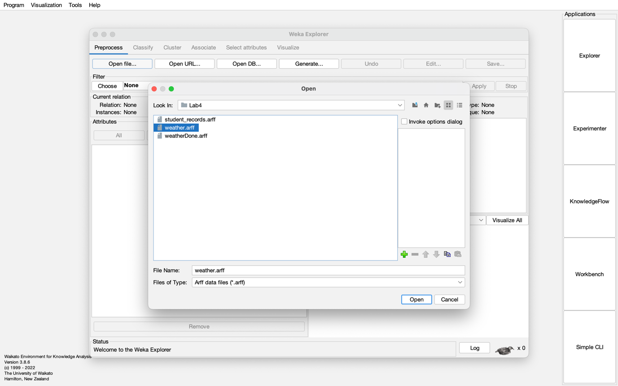

Figure 1: Selecting the Appropriate Primary Dataset

**Step 2: Loading the Dataset**

After selecting the dataset, it must be loaded into Weka. Once loaded, it’s important to verify that all attributes and instances are correctly displayed, ensuring there are no missing or erroneous values.

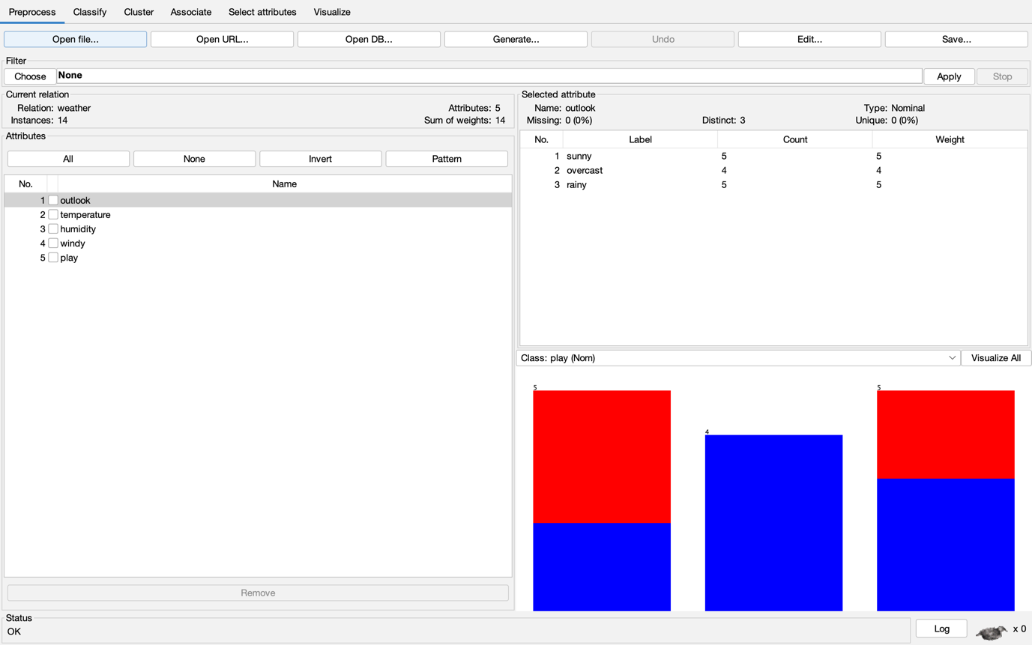

Figure 2: Loading the Nominal Dataset

**Step 3: Choosing the K-Means Algorithm**

To apply K-Means clustering in Weka:

* Navigate to the "Cluster" tab.
* Click the "Choose" button.
* Select SimpleKMeans from the list of available clustering algorithms to begin the clustering process.

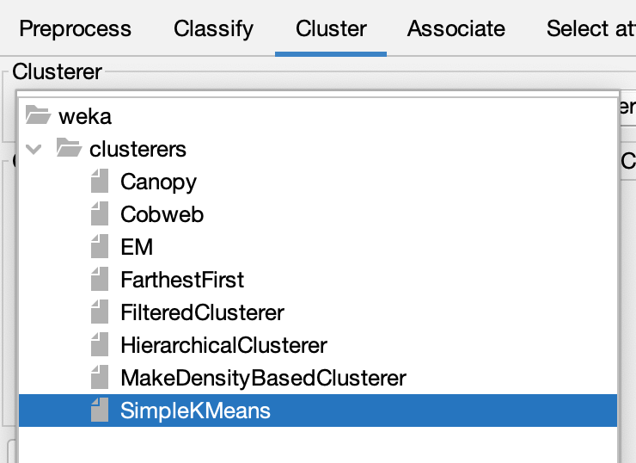

Figure 3: Choose SimpleKMeans

**Step 4: Configuring K-Means**

Before running the algorithm, configure the necessary parameters:

* Click on SimpleKMeans to open the settings window.
* Set the number of clusters to 2, meaning the data will be divided into two groups.
* Adjust any additional settings, such as maximum iterations or random seed, if needed.

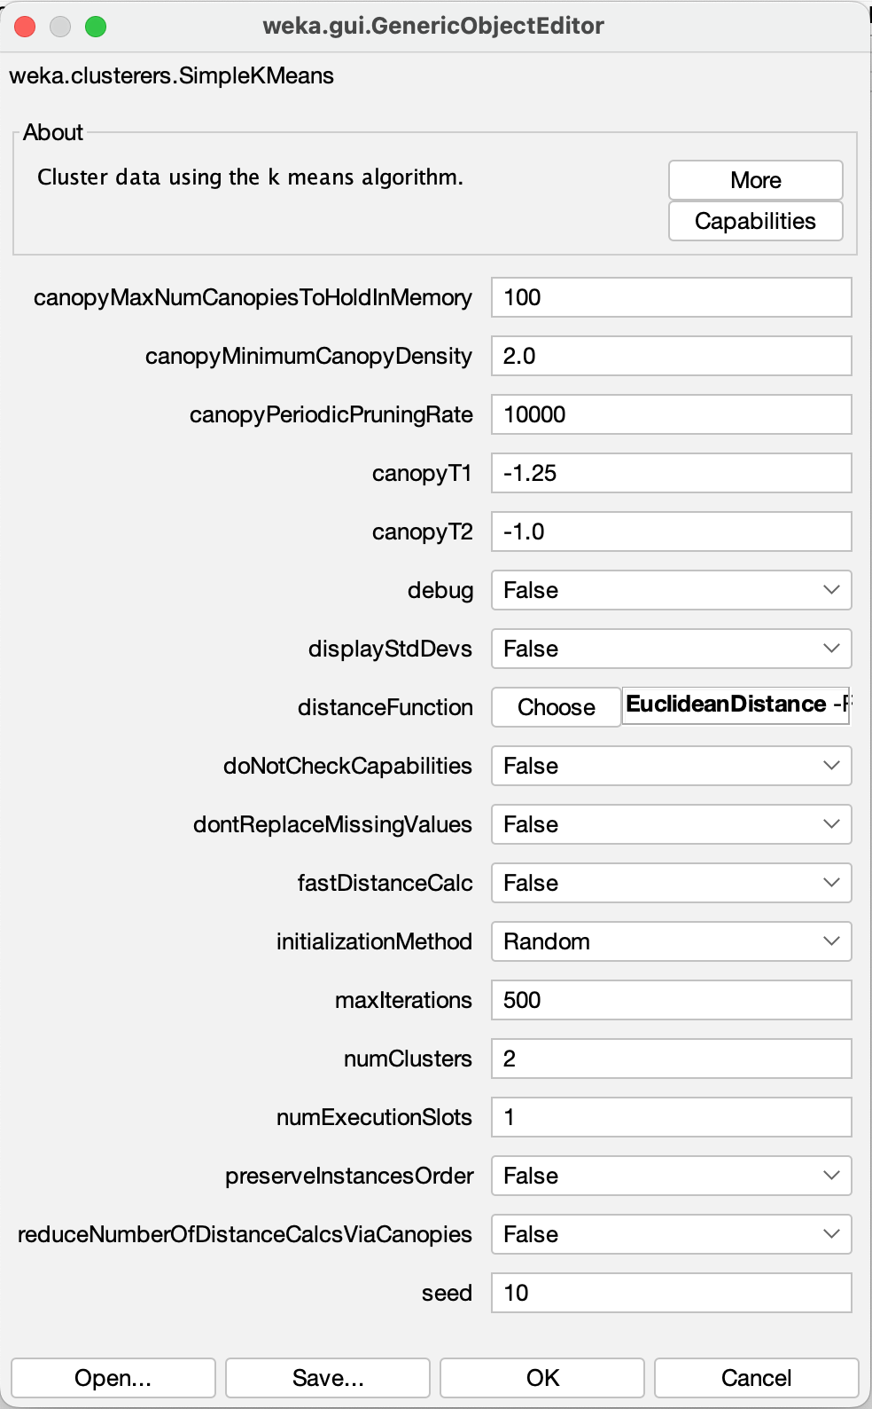

Figure 4: Configure K-Means

**Step 5: Running Simple K-Means**

Once the configurations are complete:

* Click Start to execute the K-Means clustering algorithm.
* The algorithm processes the data, assigning instances to their respective clusters based on similarities.
* The output window will display key details such as cluster centroids and the distribution of data points across clusters.

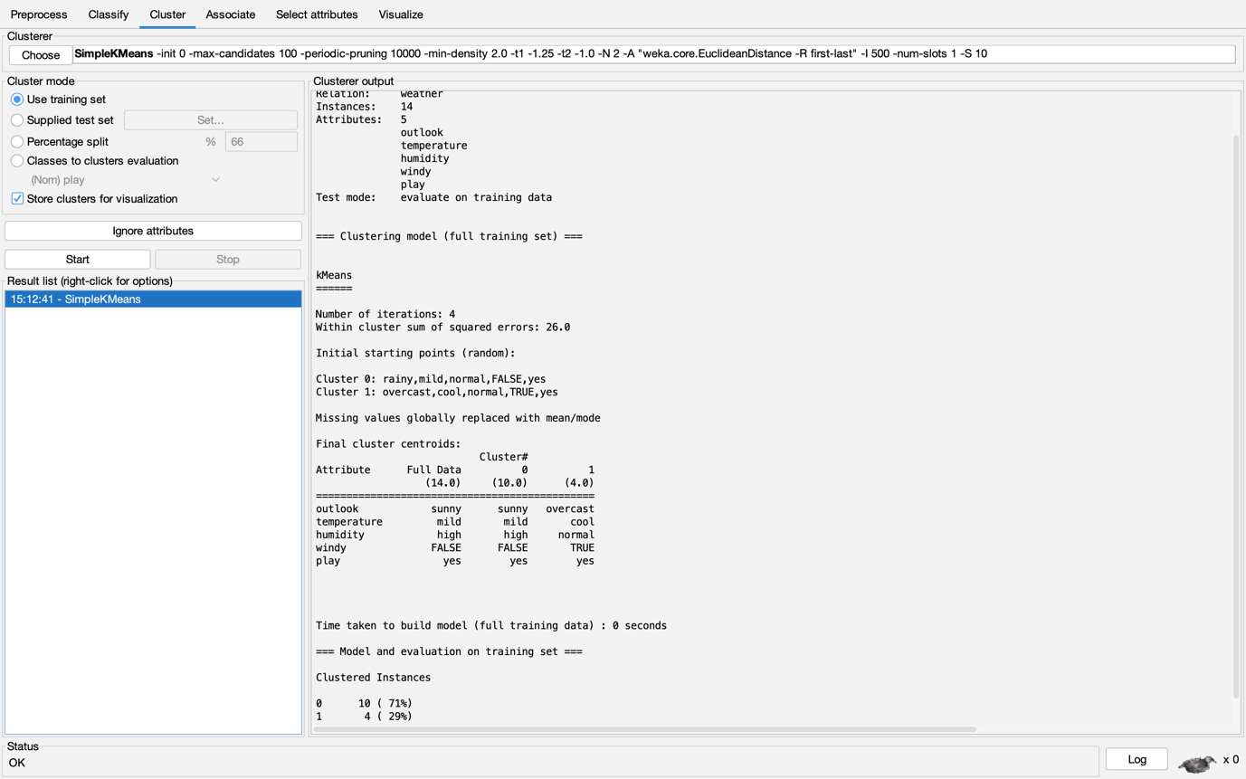

Figure 5: Output of K-Means Clustering

**Step 6: Visualizing the Clusters**

After clustering, visualization can help better interpret the results:

* Go to the "Cluster" tab and locate the results panel.
* Click Visualize to open the visualization window.
* Choose attributes for the x-axis and y-axis to plot the data points.
* The graph will show data points in different colors based on their assigned clusters, aiding in the interpretation of the cluster formations.

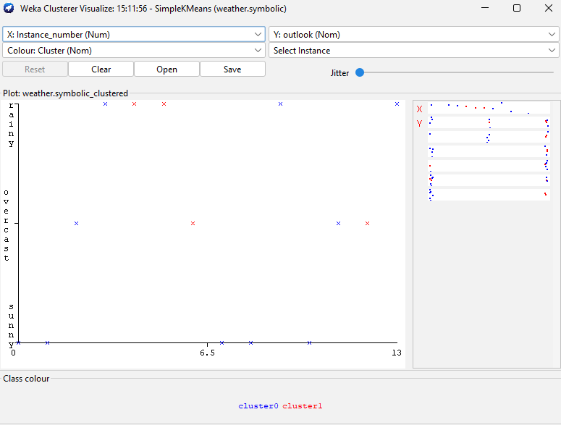

Figure 2: Data Visualization of K-means Clustering

### Discussion:

### The K-Means algorithm effectively grouped the **Tennis dataset** into two clusters, based on weather conditions, providing insights into how weather influences tennis playability. The clustering helped identify patterns, though the method's reliance on predefining the number of clusters (K) and its sensitivity to initial centroid placement can be limitations.

### Conclusion:

### By applying **K-Means clustering** with **K=2** to the **Tennis dataset**, we successfully grouped data into meaningful clusters, gaining valuable insights into weather conditions affecting tennis playability. This demonstrates K-Means as a useful tool for discovering patterns and making data-driven decisions.

**ST. XAVIER’S COLLEGE**

**Maitighar, Kathmandu**

**(Affiliated to Tribhuvan University)**



**LAB REPORT ON**

**DATA MINING AND DATA WAREHOUSING (IT 308)**

**SUBMITTED BY:** **SUBMITTED TO:**

**Name: Shashank Acharya Er. Anuj Shrestha**

**Faculty/Semester: BIM/8th (NEC Registration No.:5495)**

**Roll No.: 020BIM045 Lecturer,**

**Dept. of Computer Science**

# Lab Number: 10

**Title**: Hierarchical Clustering with Weka: Implementation and Dendrogram Visualization

**Objective**: The aim of this lab is to implement **Hierarchical Clustering** using Weka, visualize the dataset and its clustered results, and generate a **dendrogram** to illustrate the hierarchical relationships between clusters.

**Tools used**: Weka.

# Theory:

Clustering is an **unsupervised learning** technique that group data points based on their similarity. The goal is to partition the dataset into clusters where items in the same cluster are more similar to each other than to those in different clusters.

### **Hierarchical Clustering:**

Hierarchical clustering organizes data into a **hierarchical structure** and can be done using two approaches:

1. **Agglomerative (Bottom-Up):**
   * Each data point starts as its own cluster.
   * Clusters are merged based on similarity until all points form a single cluster.
2. **Divisive (Top-Down):**
   * Starts with all data points in one cluster.
   * Clusters are recursively split into smaller clusters based on distance.

### **Types of Hierarchical Clustering:**

1. **Agglomerative Clustering:**
   * Begins with individual points as separate clusters.
   * Clusters are merged based on proximity until all points are in one cluster.
2. **Divisive Clustering:**
   * Starts with a single cluster containing all points.
   * Splits iteratively until each point becomes its own cluster.

### **Distance Metrics:**

* **Euclidean Distance:** Straight-line distance between two points.
* **Manhattan Distance:** Sum of absolute differences between coordinates.
* **Cosine Similarity:** Measures the cosine of the angle between two points.

### **Linkage Methods:**

* **Single Linkage:** Uses the shortest distance between clusters.
* **Complete Linkage:** Uses the longest distance between clusters.
* **Average Linkage:** Uses the average distance between clusters.

### **Dendrogram:**

A **dendrogram** is a tree-like diagram that shows how clusters are merged or split, representing the hierarchical structure of the data.

### **Steps for Performing Hierarchical Clustering in WEKA:**

1. **Load the Dataset:**
   * Open **WEKA**, navigate to the **Explorer** window.
   * Import your dataset (e.g., **Tennis dataset in .arff format).**
   * Ensure the data is numerically encoded and free from missing values.
2. **Select the Clustering Algorithm:**
   * Go to the **Cluster** tab.
   * Choose **HierarchicalClusterer** from the list of clustering algorithms.
   * Set the number of clusters and select the desired **linkage method** (Single, Complete, Average) and **distance function** (e.g., Euclidean, Manhattan).
3. **Execute the Algorithm:**
   * Click **Start** to run the algorithm.
   * The algorithm will merge or split clusters based on the chosen criteria and generate a dendrogram.
4. **Visualize the Dendrogram:**
   * Right-click the result in the **Result List** and select **Visualize Tree** to view the dendrogram.
   * The dendrogram shows how data points are grouped hierarchically.

### **Results:**

After running the algorithm on the **Tennis dataset**, it was divided into two clusters based on weather conditions. The dendrogram effectively illustrated the hierarchical structure:

* **Cluster 1:** Data points with **Outlook = Sunny** and **Wind = Weak**.
* **Cluster 2:** Data points with **Outlook = Rain** and **Wind = Strong**.

The **dendrogram** provided a visual representation of how the features influence cluster formation and the relationships between data points.

### **Implementation of Hierarchical Clustering in WEKA**

Here’s a step-by-step guide for performing **Hierarchical Clustering** using WEKA:

#### **Step 1: Select the Primary Dataset**

The first step is to choose a dataset that is suitable for clustering. The dataset should be in the correct format (usually **.arff**), which contains both data and metadata. Ensure the dataset has meaningful attributes for clustering.

**Example Dataset:** Tennis data, customer behavior data, etc.

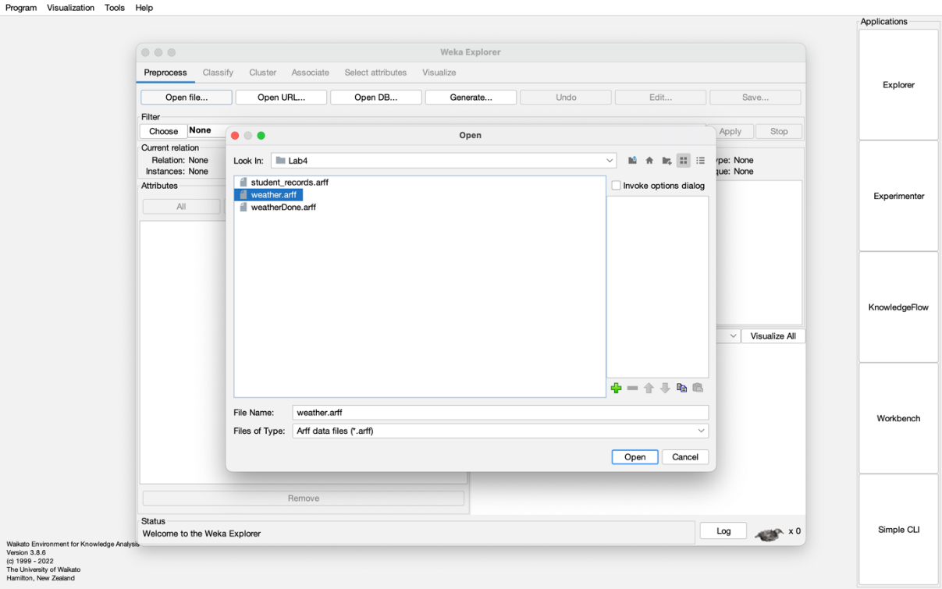

Figure 1: Selecting the Appropriate Primary Dataset

**Step 2: Load the Dataset**

* After selecting your dataset, **load** it into WEKA.
* Verify that all the **attributes** and **instances** are loaded properly, ensuring the dataset is complete and error-free.

errors.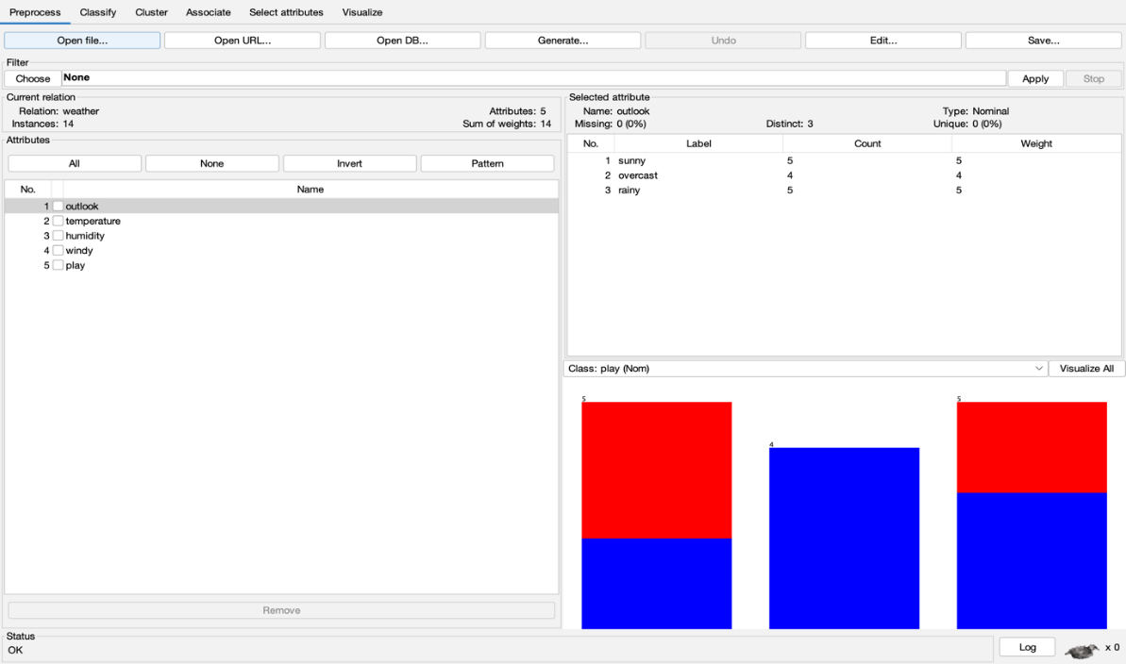

Figure 2: Loading the Nominal Dataset

**Step 3: Choose Hierarchical Clustering**  
 To apply hierarchical clustering:

* Navigate to the **Cluster** tab.
* Click on the **Choose** button to select the clustering algorithm.
* From the list, select **HierarchicalClusterer**.

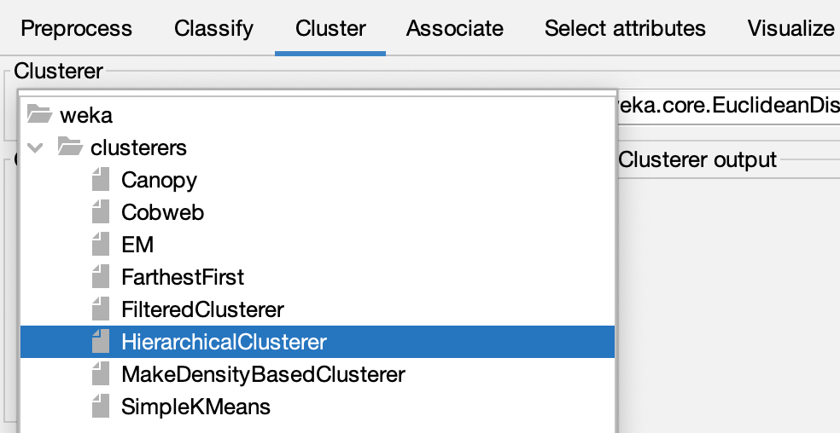

Figure 3: Choose Hierarchical Clustering

**Step 4: Configure the Hierarchical Clustering Algorithm**

* After selecting the algorithm, click on it to open the configuration panel.
* Set the **number of clusters** (e.g., **2** clusters) that the algorithm will create.
* Adjust other parameters, such as:
* Linkage Method: Choose between Single Linkage, Complete Linkage, or Average Linkage.
* Distance Metric: You can select Euclidean Distance, Manhattan Distance, etc.
* Maximum Iterations or Random Seed if necessary.

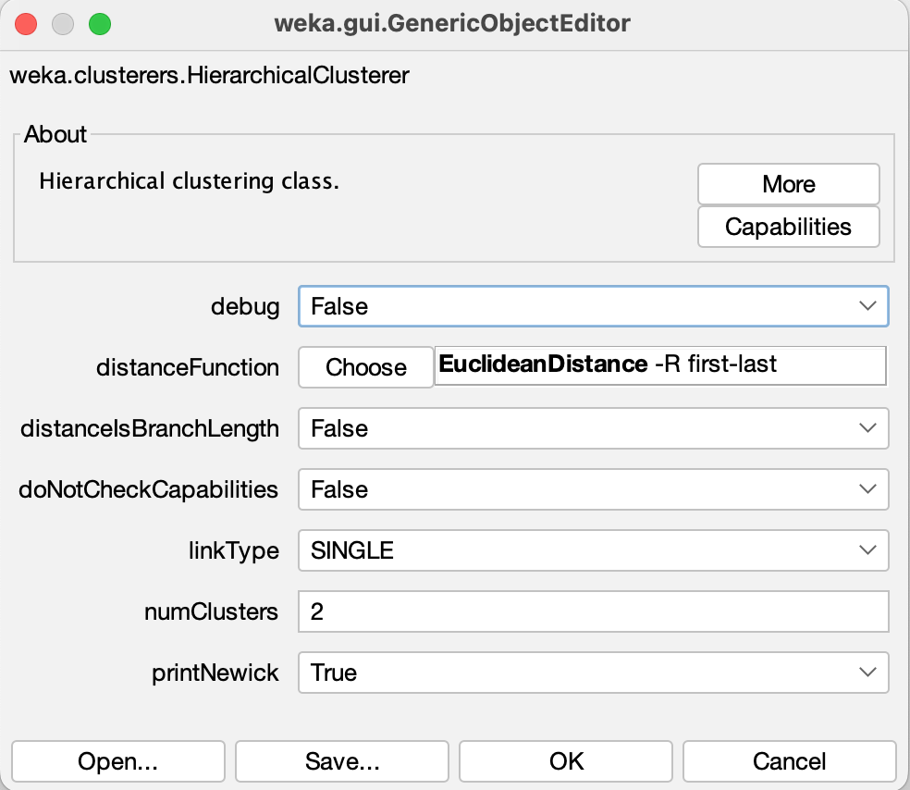

Figure 4: Configure Hierarchical Clustering Algorithm

**Step 5: Execute the Hierarchical Clustering Algorithm**

* Click the **Start** button to run the **Hierarchical Clustering** algorithm.
* The algorithm will group the data points into clusters based on their similarity, using the attributes you selected.

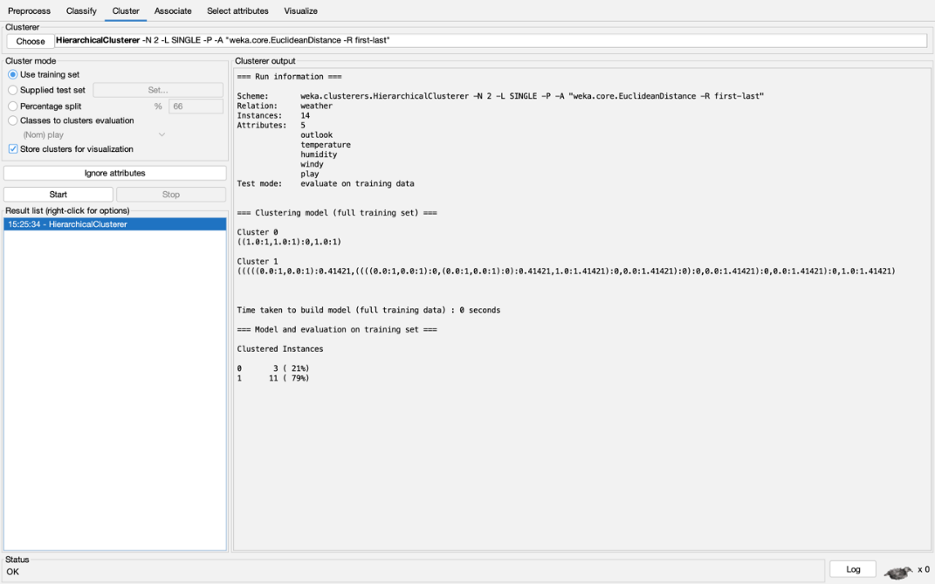

Figure 5: Output of Hierarchical Clustering Algorithm

**Step 6: Visualize the Clustering Results**

* After the algorithm finishes, navigate to the **Cluster** tab to view the results.
* Click on the **Visualize** button to observe a graphical representation (dendrogram) of the clustered data.
* The dendrogram shows how clusters are formed and merged or split over time.

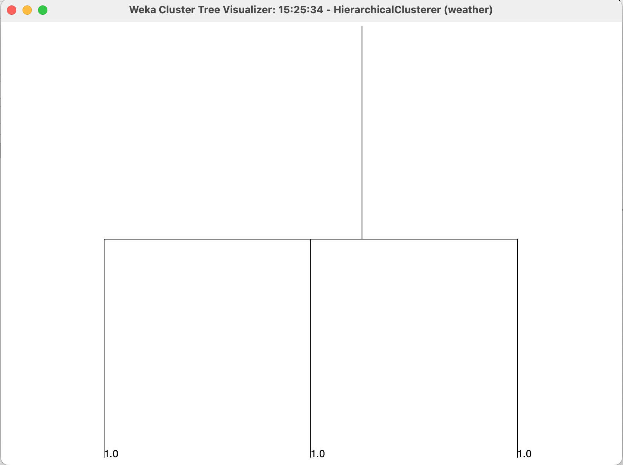

Figure 6: Data Visualization of Hierarchical Clustering

### **Conclusion**

In this experiment, we successfully implemented Hierarchical Clustering using WEKA, dividing the dataset into clusters based on similarity and visualizing the results with a dendrogram.

Advantages include the ability to create an interpretable hierarchical structure and the flexibility of not needing to predefine the number of clusters. However, the choice of distance metric and linkage method can impact the results, so careful selection is necessary.

Considerations include the potential computational cost for large datasets, making it less efficient compared to methods like K-means. Despite this, hierarchical clustering is valuable for understanding relationships between clusters.

**ST. XAVIER’S COLLEGE**

**Maitighar, Kathmandu**

**(Affiliated to Tribhuvan University)**



**LAB REPORT ON**

**DATA MINING AND DATA WAREHOUSING (IT 308)**

**SUBMITTED BY:** **SUBMITTED TO:**

**Name: Shashank Acharya Er. Anuj Shrestha**

**Faculty/Semester: BIM/8th (NEC Registration No.:5495)**

**Roll No.: 020BIM045 s Lecturer,**

**Dept. of Computer Science**

# Lab Number: 11

**Title**: Density-Based Clustering Using Weka: Analysis of Dataset Clustering Based on Density Connectivity

**Objective**: The objective of this lab is to implement Density-Based Spatial Clustering of Applications with Noise (DBSCAN) using Weka. This includes preprocessing the dataset, configuring DBSCAN parameters such as epsilon and minimum points, performing clustering, and visualizing the resulting clusters and outliers.

**Tools used**: Weka.

# Theory:

#### Clustering is the process of organizing data points into groups (clusters) based on their similarity, where points in the same group are more alike than those in different groups. One effective clustering method is density-based clustering, which forms clusters by identifying dense regions in the data.

#### **DBSCAN (Density-Based Spatial Clustering of Applications with Noise)**

#### DBSCAN is a popular density-based clustering algorithm that can efficiently handle noisy data and detect clusters of arbitrary shapes. Unlike partitioning methods like K-means, DBSCAN groups data points based on their density and does not require the number of clusters to be pre-specified.

#### **Key Concepts**

* ε (Epsilon): This parameter defines the radius within which data points are considered neighbors.
* MinPts (Minimum Points): Specifies the minimum number of points needed within the ε-radius to form a dense cluster.
* Core Point: A point that has at least MinPts points within its ε-radius.
* Border Point: A point that lies within the neighborhood of a core point but doesn’t meet the MinPts requirement.
* Noise Point: A point that doesn't belong to any cluster and is considered an outlier.

#### **Algorithm Steps**

1. Initialization: The algorithm starts by selecting a random data point.
2. Finding Neighbors: If the selected point has at least MinPts neighbors within a radius of ε, it is classified as a core point, and a new cluster begins.
3. Expanding the Cluster: The algorithm expands the cluster by adding neighboring points and their neighbors iteratively until no more points can be included.
4. Identifying Noise: Points that do not belong to any cluster are labeled as noise.

#### **Advantages of DBSCAN**

* Outlier Detection: DBSCAN can effectively identify noise points, making it robust to outliers.
* Arbitrary Shape Clusters: It can identify clusters with irregular shapes, unlike K-means, which assumes clusters to be spherical.
* No Need for Predefined Cluster Count: Unlike K-means, DBSCAN does not require specifying the number of clusters in advance.

#### **Limitations**

* Parameter Sensitivity: Choosing the correct values for ε and MinPts can be difficult, as they significantly affect the clustering results.
* Varying Cluster Densities: DBSCAN may struggle when dealing with datasets containing clusters of varying densities, which can lead to incorrect classifications.

**Implementation**

## Steps for using Density-based Clustering Algorithm

#### **Step 1: Selecting the Primary Dataset**

The first step in the clustering process is selecting a relevant dataset that is properly formatted. Weka supports datasets in the .arff (Attribute-Relation File Format), which includes both the data and metadata necessary for analysis.



Figure 1: Selecting the Appropriate Primary Dataset

**Step 2: Loading the Dataset**

After selecting the dataset, it needs to be loaded into Weka. It's important to verify that all attributes and instances are correctly imported to avoid any inconsistencies in the data.



Figure 2: Loading the Nominal Dataset

### Step 3: Choosing MakeDensityBasedClusterer from the Clustering Section

### To perform density-based clustering in Weka:

### Open the "Cluster" tab.

### Click the "Choose" button.

### Select "MakeDensityBasedClusterer" from the list of available clustering algorithms.

### 

Figure 3: Choose MakeDensityBasedClusterer

**Step 4: Configuring MakeDensityBasedClusterer**

In this step, the parameters for the MakeDensityBasedClusterer algorithm need to be configured:

* Click on "MakeDensityBasedClusterer" to open the settings window.
* Adjust parameters such as ε (epsilon) and MinPts to fine-tune the clustering performance.

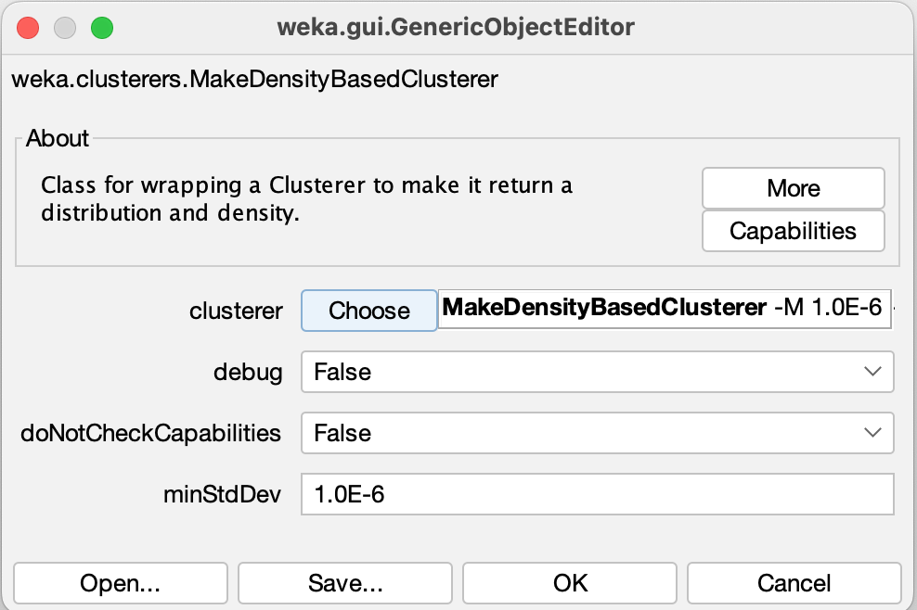

Figure 4: Configure MakeDensityBasedClusterer Algorithm

**Step 5: Running the MakeDensityBasedClusterer Algorithm**

Once the configuration is complete, execute the algorithm:

* Click the "Start" button to begin the clustering process.
* The algorithm will process the dataset and categorize the data points into clusters based on their density.

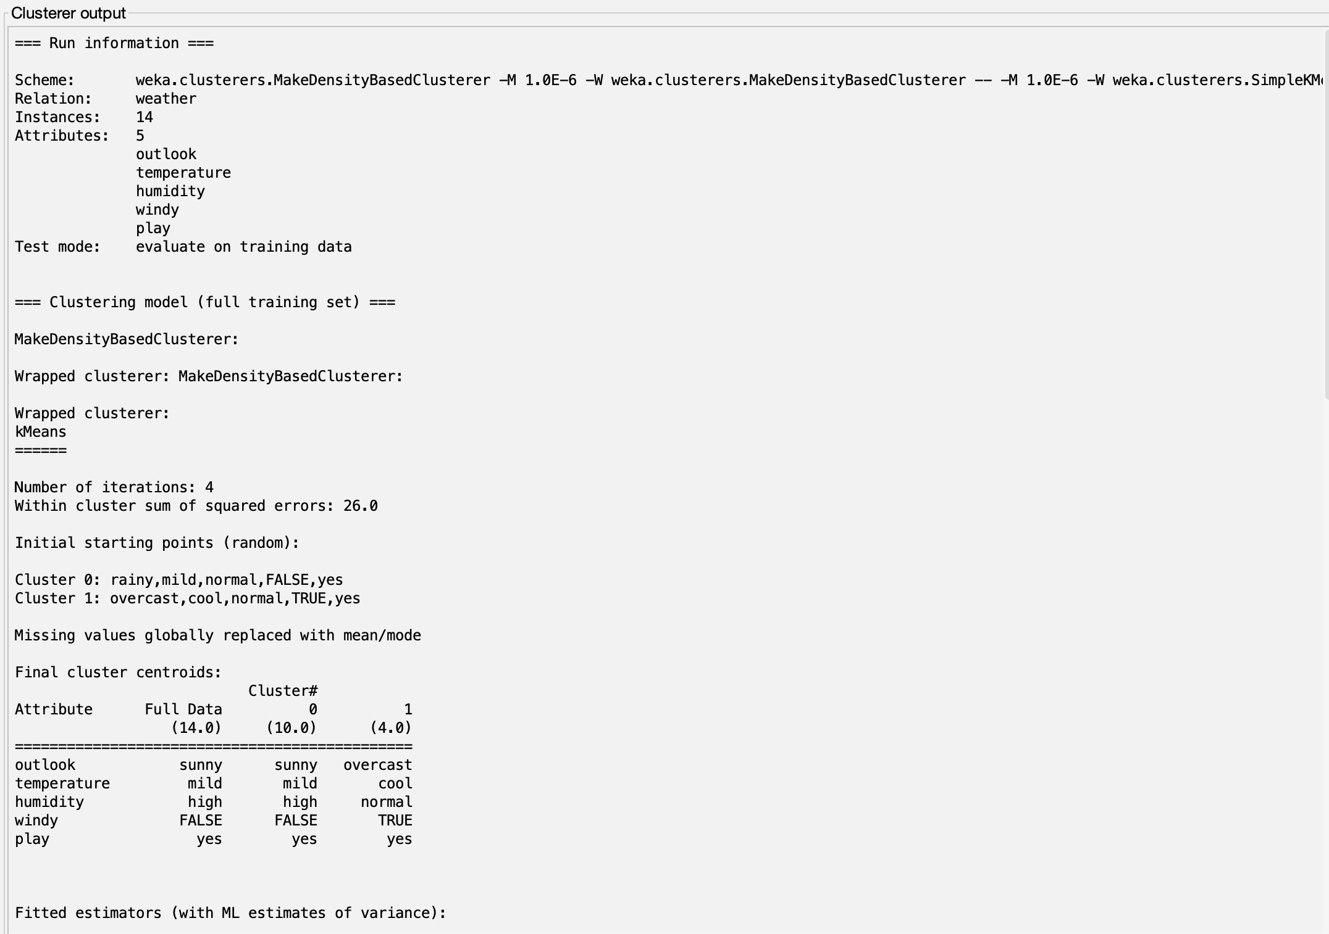

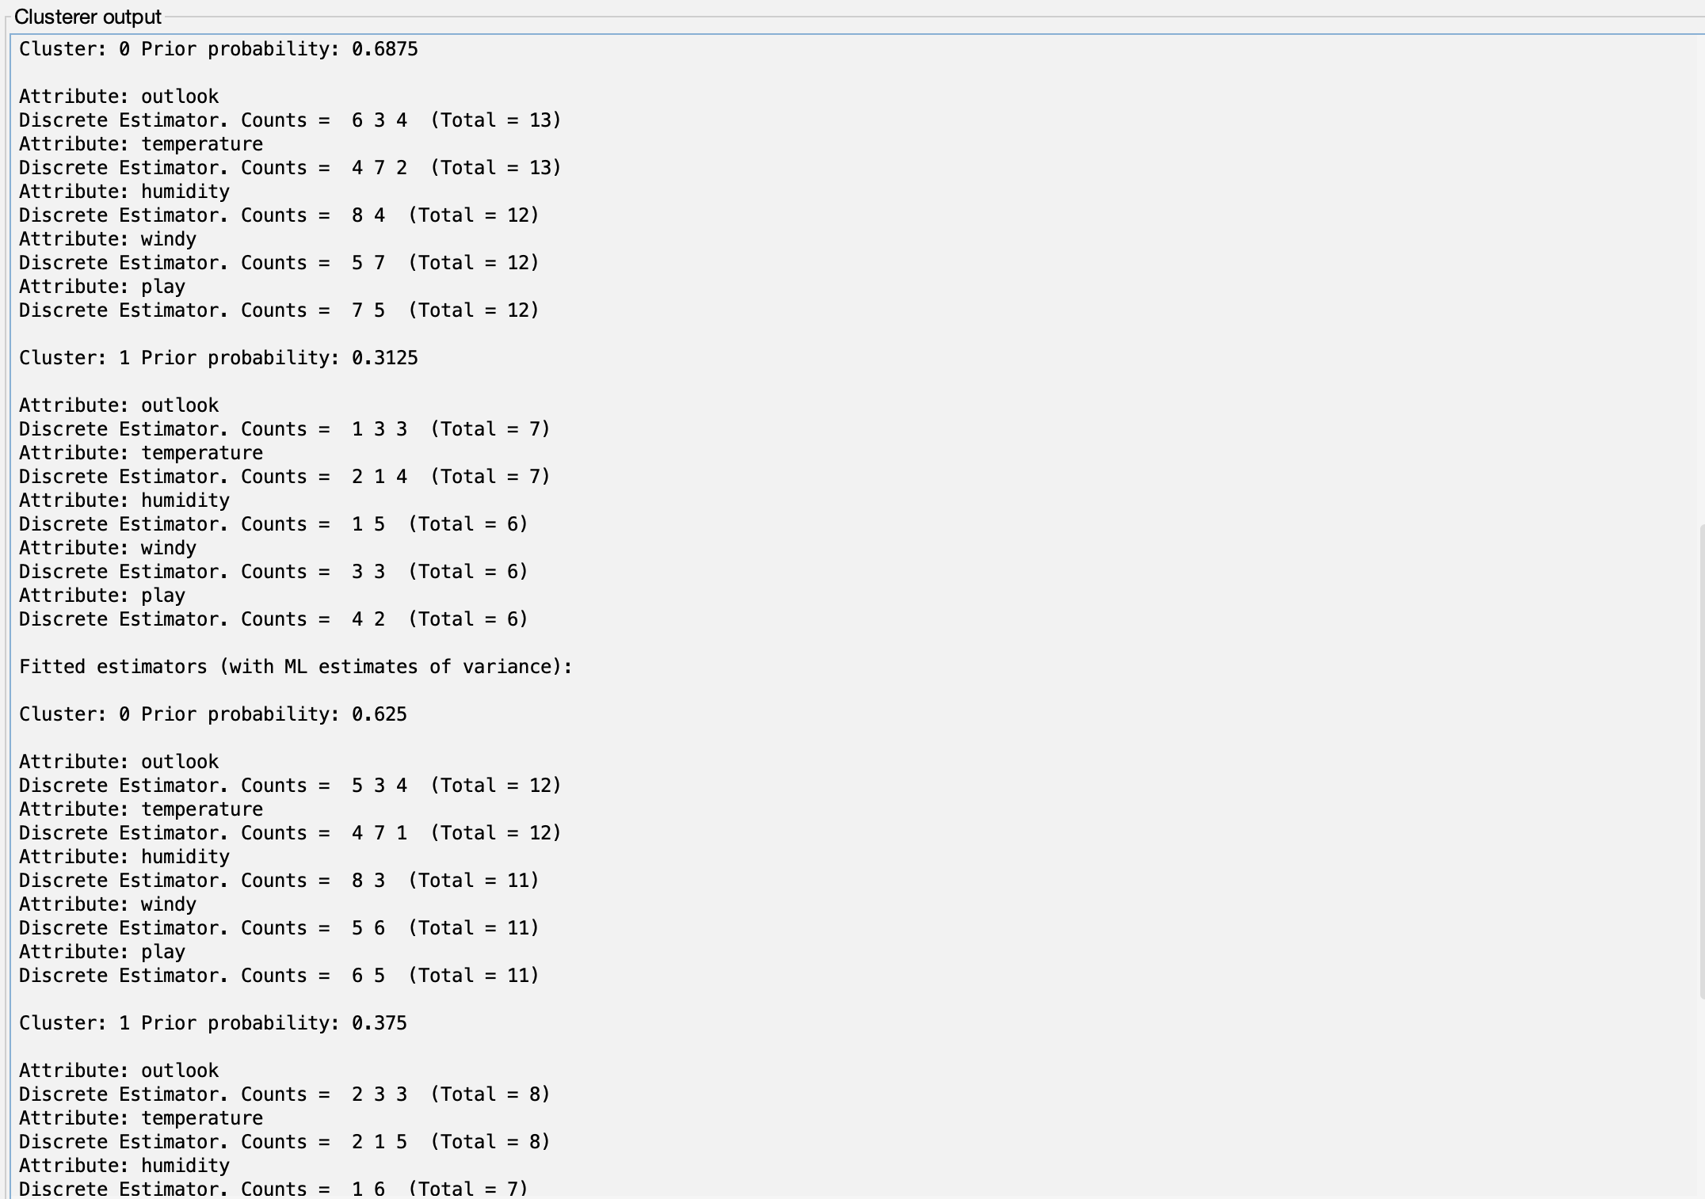

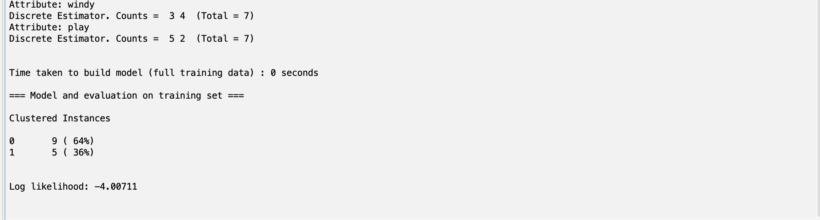

Figure 5: Output of MakeDensityBasedClusterer

**Step 6: Visualizing the Clustering Results**

To better understand the clustering results, visualize them:

* Go to the "Visualization" tab in the results panel.
* The visualization will display the distribution of clusters and potential outliers.

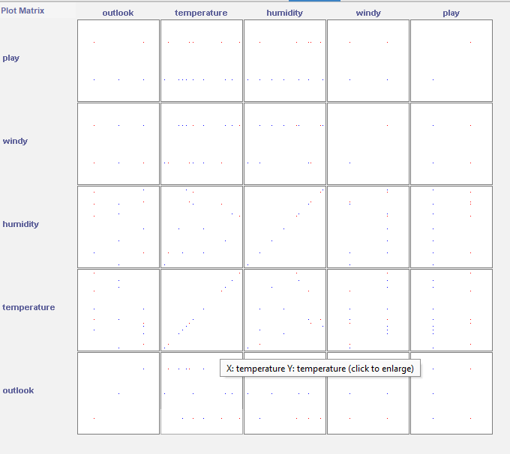

Figure 6: Data Visualization of MakeDensityBasedClusterer Clustering

### Discussion:

### The DBSCAN algorithm was applied to the Iris dataset, successfully identifying clusters without the need to know the number of clusters in advance. It also detected noise points, showcasing its ability to handle outliers. Unlike K-means clustering, DBSCAN can detect clusters of arbitrary shapes and does not require specifying the number of clusters. However, choosing the right values for ε (epsilon) and MinPts is crucial, as these parameters significantly affect clustering performance and may vary depending on the dataset’s structure.

### Conclusion:

### This experiment successfully demonstrated the use of the DBSCAN algorithm for density-based clustering on the Iris dataset. The algorithm efficiently identified clusters and noise points without needing a predefined number of clusters, making it ideal for datasets with irregular densities or noise. DBSCAN's ability to identify non-spherical clusters and handle outliers makes it a powerful tool for data mining and machine learning applications.